# **Data Warehousing and Integration Part 1**

## **What Is a Data Warehouse?**

Data warehouses serve as a central repository for storing and analyzing information to make better informed decisions. A data warehouse is a centralized storage system that allows for the storing, analyzing, and interpreting of [data](https://www.simplilearn.com/what-is-data-article) in order to facilitate better decision-making. Transactional systems, relational databases, and other sources provide data into data warehouses on a regular basis. A data warehouse is a type of [data management](https://www.simplilearn.com/what-is-data-management-article) system that facilitates and supports [business intelligence (BI)](https://www.simplilearn.com/what-is-business-intelligence-article) activities, specifically analysis. Data warehouses are primarily designed to facilitate searches and analyses and usually contain large amounts of historical data.

## Key Characteristics of Data Warehouse

* Subject – Oriented:  
  A data warehouse is subject-oriented since it provides topic-wise information rather than the overall processes of a business. Such subjects may be sales, promotion, inventory, etc. For example, if you want to analyze your company’s sales data, you need to build a data warehouse that concentrates on sales. Such a warehouse would provide valuable information like ‘who was your best customer last year?’ or ‘who is likely to be your best customer in the coming year?’
* Integrated:  
  A data warehouse is developed by integrating data from varied sources into a consistent format. The data must be stored in the warehouse in a consistent and universally acceptable manner in terms of naming, format, and coding. This facilitates effective Data Analysis.
* Non – Volatile:

Data Once entered into Data Warehouse, it must remain unchanged. All Data is read-only. Previous data is not erased when current data is entered. This helps you to analyze what has happened and when.

* Time Variant:

The data stored in a data warehouse is documented with an element of time, either explicitly or implicitly. An example of time variance in Data Warehouse is exhibited in the Primary Key, which must have an element of time like the day, week, or month.

**Data Warehouse Vs Database:**

Although DWH and Traditional Database share some similarities, they need not to be the same idea. The main difference is in the database the data is used for multiple transactional purposes. However, in DWH the data is collected in extensive scale to perform analytics. Databases provide real-time data while data warehouse stores data to perform big analytical queries.

Database is an example for OLAP systems and Data warehouse is an example for OLTP systems.

Difference between OLAP & OLTP:

OLTP stands for Online Transaction Processing and it’s primary objective is the processing of data. An OLTP administers the day to day transaction of data under 3 tier architecture (usually 3NF). Each of these transactions involves individual records made up of multiple fields. The main emphasis of OLTP is fast query processing and data integrity in multi-access environments. Some OLTP examples are credit card activity, order entry, and ATM transactions.  
OLTP Example:

The ATM centre is an example of an OLTP system. Assume that a couple has a joint bank account. One day, they arrive at different ATMs simultaneously and want to withdraw the whole amount from their bank accounts.

The user who completes the authentication procedure first, however, will be eligible to receive money. In this situation, the OLTP system ensures that the withdrawn amount is never more significant than the amount in the bank. The critical thing to remember here is that OLTP systems are designed for transactional excellence instead of data analysis.

OLAP stands for Online Analytical Processing and its primary objective is the analysis of data. It is generally described as a category of software tools used to provide data analysis for business decisions. With the help of OLAP, [data analysts](https://www.simplilearn.com/tutorials/data-analytics-tutorial/how-to-become-a-data-analyst) can get an insight into the information on multiple databases and analyze them at a time. The main emphasis of OLAP is the response time to complex queries.

For instance, a user may request that data be analysed to present a spreadsheet exhibiting all of an enterprise's clothing products sold in Kolkata in December, compare revenue figures with the ones for the same items in February, and then see a comparison of other product sales in Kolkata during the same period.  
  
The main difference between OLTP vs OLAP is that OLTP is operational, whereas OLAP is informational.

|  |  |  |
| --- | --- | --- |
| Parameters | OLTP | OLAP |
| Main characteristics | Handles a large number of small transactions on a day to day basis | Handles large volumes of data in multiple databases |
| Data source | Transactions | OLTP databases and other sources |
| Purpose | To support essential business intelligence operations in real-time | To discover hidden insights and support business decisions |
| Response time | Milliseconds | Seconds to hours (depends on the amount of data to be processed) |
| Query type | Simple | Complex |
| Database design | Normalized database for efficiency | Denormalized database for analysis |
| Audience | Market-oriented | Customer-oriented |
| Domain | Industry-specific (manufacturing, finance, etc.) | Subject-specific (sales, marketing, etc.) |
| Performance metric | Transaction throughput | Query throughput |
| Challenge | Data warehouses can be expensive to build | Strong technical knowledge and experience is required |
| Design | Designed to have fast processing and low redundancy | Designed uniquely to integrate different data sources to build a consolidated database |
| Operations | INSERT, DELETE and UPDATE commands | SELECT command |
| Updates | Short and fast updates | Updates are scheduled and done periodically |
| No. of users | Thousands of users allowed at a time | Only a few users allowed at a time |
| Space requirements | Very small (if data is archived periodically) | Very large |

Data Warehouse Architecture:

Usually, Data Warehouse architecture comprises a three-tier structure:

Bottom Tier:

Bottom tier or Data warehouse server usually represents relational database system. Backend tools are used to cleanse, transform and feed data into this layer.

Middle Tier:

The middle tier represents OLAP server this can be implemented in two ways:

The ROLAP or Relational OLAP model is extended database management system that maps multi-dimensional data process into standard relational process.

The MOLAP or Multidimensional OLAP directly acts on multi-dimensional data and operations.

Top Tier:

This is front end client interface that gets data out from DWH. It holds variety of tools like query tools, analysis tools and reporting tools and data mining tools.

How Data Warehouse Works?

Data Warehousing integrates data and information collected from various sources into one comprehensive database. For example, a data warehouse might combine customer information from an organization’s point-of-sale systems, its mailing lists, website, and comment cards. It might also incorporate confidential information about employees, salary information, etc. Businesses use such components of data warehouse to analyze customers.

Data mining is one of the features of a data warehouse that involves looking for meaningful data patterns in vast volumes of data and devising innovative strategies for increased sales and profits.

## Types of Data Warehouse:

## There are three types of Data Warehouse.

Enterprise Data Warehouse (EDW):   
This type of warehouse serves as a key or central database that facilitates decision-support services throughout the enterprise. The advantage to this type of warehouse is that it provides access to cross-organizational information, offers a unified approach to data representation, and allows running complex queries.

Operational Data Store (ODS):

This type of data warehouse refreshes in real-time. It is often preferred for routine activities like storing employee records. It is required when data warehouse systems do not support reporting needs of the business.

Data Mart:

A data mart is a subset of a data warehouse built to maintain a particular department, region, or business unit. Every department of a business has a central repository or data mart to store data. The data from the data mart is stored in the ODS periodically. The ODS then sends the data to the EDW, where it is stored and used.

Types of Data Models:

## **High-level Conceptual Data Models:**

High-level conceptual data models provide concepts for presenting data in ways that are close to the way people perceive data. A typical example is the entity relationship model, which uses main concepts like entities, attributes and relationships. An entity represents a real-world object such as an employee or a project. The entity has attributes that represent properties such as an employee’s name, address and birthdate. A relationship represents an association among entities; for example, an employee works on many projects. A relationship exists between the employee and each project.

## **Record-based Logical Data Models:**

Record-based logical data models provide concepts users can understand but are not too far from the way data is stored in the computer. Three well-known data models of this type are relational data models, network data models and hierarchical data models.

* The *relational model* represents data as *relations*, or tables. For example, in the membership system at Science World, each membership has many members (see Figure 2.2 in Chapter 2). The membership identifier, expiry date and address information are fields in the membership. The members are individuals such as Mickey, Minnie, Mighty, Door, Tom, King, Man and Moose. Each record is said to be an *instance* of the membership table.
* The *network model* represents data as record types. This model also represents a limited type of one to many relationship called a *set type*, as shown in Figure 4.1.

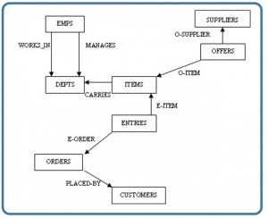

* The *hierarchical model* represents data as a hierarchical tree structure. Each branch of the hierarchy represents a number of related records. Figure 4.2 shows this schema in hierarchical model notation.

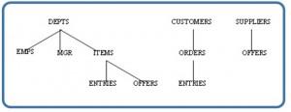

EER is an advanced version of ER that allows more detailed representation of real-world scenarios using specialization, generalization, and aggregation.

Data Modelling:

*Data modelling* is the first step in the process of database design. This step is sometimes considered to be a high-level and abstract design phase, also referred to as conceptual design. The aim of this phase is to describe:

* The data contained in the database (e.g., entities: students, lecturers, courses, subjects)
* The relationships between data items (e.g., students are supervised by lecturers; lecturers teach courses)
* The constraints on data (e.g., student number has exactly eight digits; a subject has four or six units of credit only)

In the second step, the data items, the relationships and the constraints are all expressed using the concepts provided by the high-level data model. Because these concmepts do not include the implementation details, the result of the data modelling process is a (semi) formal representation of the database structure.

The third step is database design. During this step, we might have two sub-steps: one called *database logical design*, which defines a database in a data model of a specific DBMS, and another called *database physical design*, which defines the internal database storage structure.

## **Degrees of Data Abstraction:**

In this section we will look at the database design process in terms of specificity. Just as any design starts at a high level and proceeds to an ever-increasing level of detail, so does database design. For example, when building a home, you start with how many bedrooms and bathrooms the home will have, whether it will be on one level or multiple levels, etc. The next step is to get an architect to design the home from a more structured perspective. This level gets more detailed with respect to actual room sizes, how the home will be wired, where the plumbing fixtures will be placed, etc. The last step is to hire a contractor to build the home. That’s looking at the design from a high level of abstraction to an increasing level of detail.

The database design is very much like that. It starts with users identifying the business rules; then the database designers and analysts create the database design; and then the database administrator implements the design using a DBMS.

The following subsections summarize the models in order of decreasing level of abstraction.

### External models

* Represent the user’s view of the database
* Contain multiple different external views
* Are closely related to the real world as perceived by each user

### Conceptual models

* Provide flexible data-structuring capabilities
* Present a “community view”: the logical structure of the entire database
* Contain data stored in the database
* Show relationships among data including:
  + Constraints
  + Semantic information (e.g., business rules)
  + Security and integrity information
* Consider a database as a collection of entities (objects) of various kinds
* Are the basis for identification and high-level description of main data objects; they avoid details
* Are database independent regardless of the database you will be using

## **Data Abstraction Layer**

In a pictorial view, you can see how the different models work together. Let’s look at this from the highest level, the external model.

The external model is the end user’s view of the data. Typically a database is an enterprise system that serves the needs of multiple departments. However, one department is not interested in seeing other departments’ data (e.g., the human resources (HR) department does not care to view the sales department’s data). Therefore, one user view will differ from another.

The external model requires that the designer subdivide a set of requirements and constraints into functional modules that can be examined within the framework of their external models (e.g., human resources versus sales).

As a data designer, you need to understand all the data so that you can build an enterprise-wide database. Based on the needs of various departments, the conceptual model is the first model created.

At this stage, the conceptual model is independent of both software and hardware. It does not depend on the DBMS software used to implement the model. It does not depend on the hardware used in the implementation of the model. Changes in either hardware or DBMS software have no effect on the database design at the conceptual level.

Once a DBMS is selected, you can then implement it. This is the internal model. Here you create all the tables, constraints, keys, rules, etc. This is often referred to as the *logical design*.

The physical model is simply the way the data is stored on disk. Each database vendor has its own way of storing the data.

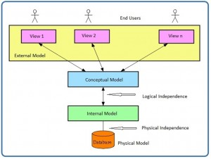

## **Schemas**

A *schema* is an overall description of a database, and it is usually represented by the *entity relationship diagram (ERD)*. There are many subschemas that represent external models and thus display external views of the data. Below is a list of items to consider during the design process of a database.

* External schemas: there are multiple
* Multiple subschemas: these display multiple external views of the data
* Conceptual schema: there is only one. This schema includes data items, relationships and constraints, all represented in an ERD.
* Physical schema: there is only one

## **Logical and Physical Data Independence**

*Data independence* refers to the immunity of user applications to changes made in the definition and organization of data. Data abstractions expose only those items that are important or pertinent to the user. Complexity is hidden from the database user.

Data independence and operation independence together form the feature of data abstraction. There are two types of data independence: logical and physical.

### Logical data independence

A *logical schema* is a conceptual design of the database done on paper or a whiteboard, much like architectural drawings for a house. The ability to change the logical schema, without changing the *external schema* or user view, is called *logical data independence*. For example, the addition or removal of new entities, attributes or relationships to this *conceptual schema* should be possible without having to change existing external schemas or rewrite existing application programs.

In other words, changes to the logical schema (e.g., alterations to the structure of the database like adding a column or other tables) should not affect the function of the application (external views).

### Physical data independence

*Physical data independence* refers to the immunity of the internal model to changes in the physical model. The logical schema stays unchanged even though changes are made to file organization or storage structures, storage devices or indexing strategy.

Physical data independence deals with hiding the details of the storage structure from user applications. The applications should not be involved with these issues, since there is no difference in the operation carried out against the data.

Assignment:

Question 1

We are modeling different modes of transport in a database model. In the EER diagram, we have a "Vehicle" superclass with two subclasses, "Car" and "Motorcycle."

Which type of generalization would allow for vehicles (for example: ships) that are neither cars nor motorcycles?

1. Partial Generation

Question 2

Consider a university database in which each course has multiple sections, and each section is uniquely identified by a section number within that course. Each section has attributes such as the time it meets, the classroom, and the instructor. The section number is only unique within the context of a specific course.

Write the True regarding the section entity in an EER diagram scenario

A. Section is weak entity that depends on “Course” for Identification

Question 3.

A travel agency specializes in holidays to Southeast Asia. Customized holidays are set up and handled by an agency rep. The rep creates a new booking, identified by an ID. Each booking also references hotel, hotel room, check-in dates, and number of nights. Once a customer has chosen a hotel and hotel room, they can add up to three excursions that are offered within the vicinity of the hotel. Hotels and excursions are referred to as itineraries, and customers can assign one or more itineraries to a booking. Often the customer making the booking is not the one going on holiday; therefore, each booking has an assigned set of travelers.  
 A.Hotel and excursion can be modelled as an aggregate called itineraries.

# Logical Database Design:

The relational data model was introduced by E. F. Codd in 1970. Currently, it is the most widely used data model.

The relational model has provided the basis for:

* Research on the theory of data/relationship/constraint
* Numerous database design methodologies
* The standard database access language called s*tructured query language (SQL)*
* Almost all modern commercial database management systems

The relational data model describes the world as “a collection of inter-related relations (or tables).”

## **Fundamental Concepts in the Relational Data Model**

### Relation

A *relation,* also known as a *table* or *file*, is a subset of the Cartesian product of a list of domains characterized by a name. And within a table, each row represents a group of related data values. A *row*, or record, is also known as a *tuple*. The columns in a table is a field and is also referred to as an attribute. You can also think of it this way: an attribute is used to define the record and a record contains a set of attributes.

The steps below outline the logic between a relation and its domains.

1. Given *n* domains are denoted by D1, D2, … Dn
2. And *r* is a relation defined on these domains
3. Then r ⊆ D1×D2×…×Dn

### Table

A database is composed of multiple tables and eachtable holds the data. Figure 7.1 shows a database that contains three tables.

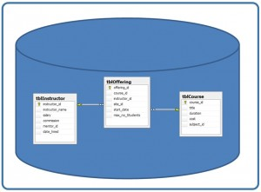

Integrity Rules and Constraints:

Constraints are important feature in relational Data Model. In fact, the relational model that supports the well-defined theory of constraints on attributes or tables. Constraints are useful because they allow the designer to specify the semantics of data in database. Constraints are the rules that force DBMS to check data satisfies the semantics.

## **Domain Integrity:**

Domain restricts the values of attributes in the relation and is a constraint of the relational model. However, there are real-world semantics for data that cannot be specified if used only with domain constraints. We need more specific ways to state what data values are or are not allowed and which format is suitable for an attribute. For example, the Employee ID (EID) must be unique or the employee Birthdate is in the range [Jan 1, 1950, Jan 1, 2000]. Such information is provided in logical statements called *integrity constraints*.

There are several kinds of integrity constraints, described below.

### **Entity integrity**

To ensure *entity integrity*, it is required that every table have a primary key. Neither the PK nor any part of it can contain null values. This is because null values for the primary key mean we cannot identify some rows. For example, in the EMPLOYEE table, Phone cannot be a primary key since some people may not have a telephone.

### **Referential integrity**

*Referential integrity* requires that a foreign key must have a matching primary key or it must be null. This constraint is specified between two tables (parent and child); it maintains the correspondence between rows in these tables. It means the reference from a row in one table to another table must be valid.

Examples of referential integrity constraint in the Customer/Order database of the Company:

* Customer(**CustID**, CustName)
* Order(**OrderID**, CustID, OrderDate)

To ensure that there are no orphan records, we need to enforce referential integrity. An *orphan record* is one whose foreign key FK value is not found in the corresponding entity – the entity where the PK is located. Recall that a typical join is between a PK and FK.

The referential integrity constraint states that the customer ID (CustID) in the Order table must match a valid CustID in the Customer table. Most relational databases have declarative referential integrity. In other words, when the tables are created the referential integrity constraints are set up.

Here is another example from a Course/Class database:

* Course(**CrsCode**, DeptCode, Description)
* Class(**CrsCode, Section**, ClassTime)

The referential integrity constraint states that CrsCode in the Class table must match a valid CrsCode in the Course table. In this situation, it’s not enough that the CrsCode and Section in the Class table make up the PK, we must also enforce referential integrity.

When setting up referential integrity it is important that the PK and FK have the same data types and come from the same domain, otherwise the relational database management system (RDBMS) will not allow the join. RDBMS is a popular database system that is based on the relational model introduced by E. F. Codd of IBM’s San Jose Research Laboratory. Relational database systems are easier to use and understand than other database systems.

### Referential integrity in Microsoft Access

In Microsoft (MS) Access, referential integrity is set up by joining the PK in the Customer table to the CustID in the Order table. See Figure 9.1 for a view of how this is done on the Edit Relationships screen in MS Access.

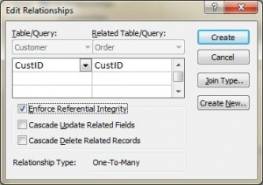

### Referential integrity using Transact-SQL (MS SQL Server)

When using Transact-SQL, the referential integrity is set when creating the Order table with the FK. Listed below are the statements showing the FK in the Order table referencing the PK in the Customer table.

CREATE TABLE Customer  
( CustID INTEGER PRIMARY KEY,  
CustName CHAR(35) )

CREATE TABLE Orders  
( OrderID INTEGER PRIMARY KEY,  
CustID INTEGER REFERENCES Customer(CustID),  
OrderDate DATETIME )

**Foreign key rules**

Additional foreign key rules may be added when setting referential integrity, such as what to do with the child rows (in the Orders table) when the record with the PK, part of the parent (Customer), is deleted or changed (updated). For example, the Edit Relationships window in MS Access (see Figure 9.1) shows two additional options for FK rules: Cascade Update and Cascade Delete. If these are not selected, the system will prevent the deletion or update of PK values in the parent table (Customer table) if a child record exists. The child record is any record with a matching PK.

In some databases, an additional option exists when selecting the Delete option called Set to Null. In this is chosen, the PK row is deleted, but the FK in the child table is set to NULL. Though this creates an orphan row, it is acceptable.

## **Enterprise Constraints**

Enterprise constraints – sometimes referred to as semantic constraints – are additional rules specified by users or database administrators and can be based on multiple tables.

Here are some examples.

* A class can have a maximum of 30 students.
* A teacher can teach a maximum of four classes per semester.
* An employee cannot take part in more than five projects.
* The salary of an employee cannot exceed the salary of the employee’s manager.

## **Business Rules**

*Business rules* are obtained from users when gathering requirements. The requirements-gathering process is very important, and its results should be verified by the user before the database design is built. If the business rules are incorrect, the design will be incorrect, and ultimately the application built will not function as expected by the users.

Some examples of business rules are:

* A teacher can teach many students.
* A class can have a maximum of 35 students.
* A course can be taught many times, but by only one instructor.
* Not all teachers teach classes.

### **Cardinality and connectivity**

Business rules are used to determine cardinality and connectivity. *Cardinality* describes the relationship between two data tables by expressing the minimum and maximum number of entity occurrences associated with one occurrence of a related entity. In Figure 9.2, you can see that cardinality is represented by the innermost markings on the relationship symbol. In this figure, the cardinality is 0 (zero) on the right and 1 (one) on the left.

In conclusion, cardinality in [DBMS](https://www.geeksforgeeks.org/dbms/introduction-of-dbms-database-management-system-set-1/) plays a crucial role in understanding the relationships between tables and the uniqueness of data within columns. By measuring the cardinality, database designers can optimize the performance and integrity of a system, ensuring efficient storage, retrieval, and management of data.

Types of cardinality in between tables are:

* One-to-One
* One-to-Many
* Many-to-One
* Many-to-Many

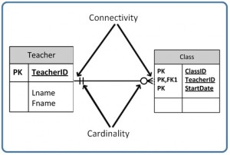

The outermost symbol of the relationship symbol, on the other hand, represents the connectivity between the two tables. *Connectivity* is the relationship between two tables, e.g., one to one or one to many. The only time it is zero is when the FK can be null. When it comes to participation, there are three options to the relationship between these entities: either 0 (zero), 1 (one) or many. In Figure 9.2, for example, the connectivity is 1 (one) on the outer, left-hand side of this line and many on the outer, right-hand side.

Figure 9.3. shows the symbol that represents a one to many relationship.

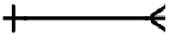*Figure 9.3.*

In Figure 9.4, both inner (representing cardinality) and outer (representing connectivity) markers are shown. The left side of this symbol is read as minimum 1 and maximum 1. On the right side, it is read as: minimum 1 and maximum many.

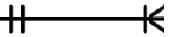

## **Relationship Types**

The line that connects two tables, in an ERD, indicates the *relationship type* between the tables*:* either identifying or non-identifying. An *identifying relationship* will have a solid line (where the PK contains the FK). A *non-identifying relationship* is indicated by a broken line and does not contain the FK in the PK. See the section in Chapter 8 that discusses weak and strong relationships for more explanation.

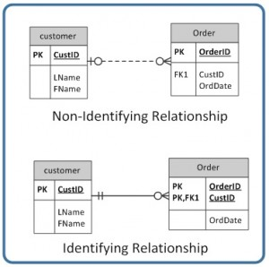

### Optional relationships

In an *optional relationship*, the FK can be null or the parent table does not need to have a corresponding child table occurrence. The symbol, shown in Figure 9.6, illustrates one type with a zero and three prongs (indicating many) which is interpreted as zero OR many.  
 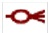

For example, if you look at the Order table on the right-hand side of Figure 9.7, you’ll notice that a customer doesn’t need to place an order to be a customer. In other words, the **many side** is optional.

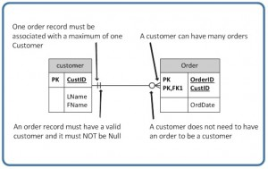

The relationship symbol in Figure 9.7 can also be read as follows:

* Left side: The order entity must contain a minimum of one related entity in the Customer table and a maximum of one related entity.
* Right side: A customer can place a minimum of zero orders or a maximum of many orders.

Figure 9.8 shows another type of optional relationship symbol with a zero and one, meaning zero OR one. The **one side** is optional.

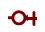

Mandatory relationships: In a *mandatory relationship*, one entity occurrence requires a corresponding entity occurrence. The symbol for this relationship shows *one and only one* as shown in Figure 9.10. The one side is mandatory.



ER Modelling

One important theory developed for the entity relational (ER) model involves the notion of functional dependency (FD). The aim of studying this is to improve your understanding of relationships among data and to gain enough formalism to assist with practical database design.

Like constraints, FDs are drawn from the semantics of the application domain. Essentially, *functional dependencies* describe how individual attributes are related. FDs are a kind of constraint among attributes within a relation and contribute to a good relational schema design. In this chapter, we will look at:

* The basic theory and definition of functional dependency
* The methodology for improving schema designs, also called normalization

## **Relational Design and Redundancy**

Generally, a good relational database design must capture all of the necessary attributes and associations. The design should do this with a minimal amount of stored information and no redundant data.

In database design, redundancy is generally undesirable because it causes problems maintaining consistency after updates. However, redundancy can sometimes lead to performance improvements; for example, when redundancy can be used in place of a *join* to connect data. A *join* is used when you need to obtain information based on two related tables.

Consider Figure 10.1: customer 1313131 is displayed twice, once for account no. A-101 and again for account A-102. In this case, the customer number is not redundant, although there are deletion anomalies with the table. Having a separate customer table would solve this problem. However, if a branch address were to change, it would have to be updated in multiple places. If the customer number was left in the table as is, then you wouldn’t need a branch table and no join would be required, and performance is improved .

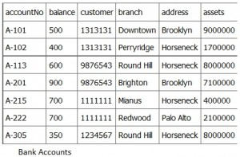

## **Insertion Anomaly**

An *insertion anomaly* occurs when you are inserting inconsistent information into a table. When we insert a new record, such as account no. A-306 in Figure 10.2, we need to check that the branch data is consistent with existing rows.

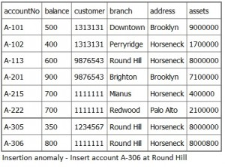

## **Update Anomaly**

If a branch changes address, such as the Round Hill branch in Figure 10.3, we need to update all rows referring to that branch. Changing existing information incorrectly is called an *update anomaly*.

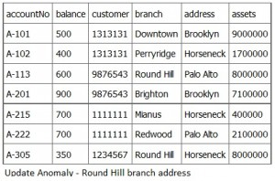

## **Deletion Anomaly**

A *deletion anomaly* occurs when you delete a record that may contain attributes that shouldn’t be deleted. For instance, if we remove information about the last account at a branch, such as account A-101 at the Downtown branch in Figure 10.4, all of the branch information disappears.

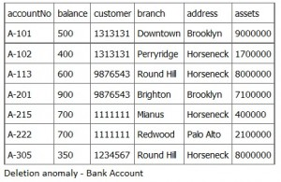

The problem with deleting the A-101 row is we don’t know where the Downtown branch is located and we lose all information regarding customer 1313131. To avoid these kinds of update or deletion problems, we need to decompose the original table into several smaller tables where each table has minimal overlap with other tables.

Each bank account table must contain information about one entity only, such as the Branch or Customer, as displayed in Figure 10.5.

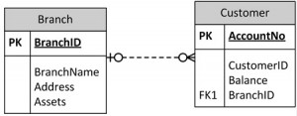

## **How to Avoid Anomalies**

The best approach to creating tables without anomalies is to ensure that the tables are normalized, and that’s accomplished by understanding functional dependencies. FD ensures that all attributes in a table belong to that table. In other words, it will eliminate redundancies and anomalies.

### Example: separate Project and Employee tables

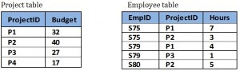

By keeping data separate using individual Project and Employee tables:

1. No anomalies will be created if a budget is changed.
2. No dummy values are needed for projects that have no employees assigned.
3. If an employee’s contribution is deleted, no important data is lost.
4. No anomalies are created if an employee’s contribution is added.

Functional Dependencies

A *functional dependency* (FD) is a relationship between two attributes, typically between the PK and other non-key attributes within a table. For any relation R, attribute Y is functionally dependent on attribute X (usually the PK), if for every valid instance of X, that value of X uniquely determines the value of Y. This relationship is indicated by the representation below :

**X ———–> Y**

The left side of the above FD diagram is called the *determinant*, and the right side is the *dependent*. Here are a few examples.

In the first example, below, SIN determines Name, Address and Birthdate. Given SIN, we can determine any of the other attributes within the table.

**SIN ———-> Name, Address, Birthdate**

For the second example, SIN and Course determine the date completed (DateCompleted). This must also work for a composite PK.

**SIN, Course ———> Date Completed**

The third example indicates that ISBN determines Title.

**ISBN ———–> Title**

## **Rules of Functional Dependencies**

Consider the following table of data r(R) of the relation schema R(ABCDE) shown in Table 11.1.

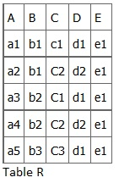

As you look at this table, ask yourself: *What kind of dependencies can we observe among the attributes in Table R?* Since the values of A are unique (a1, a2, a3, etc.), it follows from the FD definition that:

A → B, A → C, A → D, A → E

* It also follows that A →BC (or any other subset of ABCDE).
* This can be summarized as A →BCDE.
* From our understanding of primary keys, A is a primary key.

Since the values of E are always the same (all e1), it follows that:

A → E, B → E, C → E, D → E

However, we cannot generally summarize the above with ABCD → E because, in general, A → E, B → E, AB → E.

Other observations:

1. Combinations of BC are unique, therefore BC → ADE.
2. Combinations of BD are unique, therefore BD → ACE.
3. If C values match, so do D values.
   1. Therefore, C → D
   2. However, D values don’t determine C values
   3. So C does not determine D, and D does not determine C.

Looking at actual data can help clarify which attributes are dependent and which are determinants.

Normalization

Normalization should be part of the database design process. However, it is difficult to separate the normalization process from the ER modelling process so the two techniques should be used concurrently.

Use an entity relation diagram (ERD) to provide the big picture, or macro view, of an organization’s data requirements and operations. This is created through an iterative process that involves identifying relevant entities, their attributes and their relationships.

Normalization procedure focuses on characteristics of specific entities and represents the micro view of entities within the ERD.

**What Is Normalization?**

*Normalization* is the branch of relational theory that provides design insights. It is the process of determining how much redundancy exists in a table. The goals of normalization are to:

* Be able to characterize the level of redundancy in a relational schema
* Provide mechanisms for transforming schemas in order to remove redundancy

Normalization theory draws heavily on the theory of functional dependencies. Normalization theory defines six normal forms (NF). Each normal form involves a set of dependency properties that a schema must satisfy and each normal form gives guarantees about the presence and/or absence of update anomalies. This means that higher normal forms have less redundancy, and as a result, fewer update problems.

All the tables in any database can be in one of the normal forms we will discuss next. Ideally we only want minimal redundancy for PK to FK. Everything else should be derived from other tables. There are six normal forms, but we will only look at the first four, which are:

* First normal form (1NF)
* Second normal form (2NF)
* Third normal form (3NF)
* Boyce-Codd normal form (BCNF)

BCNF is rarely used.

## **First Normal Form (1NF)**

In the *first normal form*, only single values are permitted at the intersection of each row and column; hence, there are no repeating groups.

To normalize a relation that contains a repeating group, remove the repeating group and form two new relations.

The PK of the new relation is a combination of the PK of the original relation plus an attribute from the newly created relation for unique identification.

### Process for 1NF

We will use the **Student_Grade_Report** table below, from a School database, as our example to explain the process for 1NF.

**Student_Grade_Report** (StudentNo, StudentName, Major, CourseNo, CourseName, InstructorNo, InstructorName, InstructorLocation, Grade)

* In the Student Grade Report table, the repeating group is the course information. A student can take many courses.
* Remove the repeating group. In this case, it’s the course information for each student.
* Identify the PK for your new table.
* The PK must uniquely identify the attribute value (StudentNo and CourseNo).
* After removing all the attributes related to the course and student, you are left with the student course table (**StudentCourse**).
* The Student table (**Student**) is now in first normal form with the repeating group removed.
* The two new tables are shown below.

**Student** (StudentNo, StudentName, Major)

**StudentCourse** (StudentNo, CourseNo, CourseName, InstructorNo, InstructorName, InstructorLocation, Grade)

### How to update 1NF anomalies

**StudentCourse** (StudentNo, CourseNo, CourseName, InstructorNo, InstructorName, InstructorLocation, Grade)

* To add a new course, we need a student.
* When course information needs to be updated, we may have inconsistencies.
* To delete a *student,* we might also delete critical information about a course.

## **Second Normal Form (2NF)**

For the *second normal form*, the relation must first be in 1NF. The relation is automatically in 2NF if, and only if, the PK comprises a single attribute.

If the relation has a composite PK, then each non-key attribute must be fully dependent on the entire PK and not on a subset of the PK (i.e., there must be no partial dependency or augmentation).

### Process for 2NF

To move to 2NF, a table must first be in 1NF.

* The Student table is already in 2NF because it has a single-column PK.
* When examining the Student Course table, we see that not all the attributes are fully dependent on the PK; specifically, all course information. The only attribute that is fully dependent is grade.
* Identify the new table that contains the course information.
* Identify the PK for the new table.
* The three new tables are shown below.

**Student** (StudentNo, StudentName, Major)

**CourseGrade** (StudentNo, CourseNo, Grade)

**CourseInstructor** (CourseNo, CourseName, InstructorNo, InstructorName, InstructorLocation)

### How to update 2NF anomalies

* When adding a new instructor, we need a course.
* Updating course information could lead to inconsistencies for instructor information.
* Deleting a course may also delete instructor information.

## **Third Normal Form (3NF)**

To be in *third normal form*, the relation must be in second normal form. Also all transitive dependencies must be removed; a non-key attribute may not be functionally dependent on another non-key attribute.

### Process for 3NF

* Eliminate all dependent attributes in transitive relationship(s) from each of the tables that have a transitive relationship.
* Create new table(s) with removed dependency.
* Check new table(s) as well as table(s) modified to make sure that each table has a determinant and that no table contains inappropriate dependencies.
* See the four new tables below.

**Student** (StudentNo, StudentName, Major)

**CourseGrade** (StudentNo, CourseNo, Grade)

**Course** (CourseNo, CourseName, InstructorNo)

**Instructor** (InstructorNo, InstructorName, InstructorLocation)

At this stage, there should be no anomalies in third normal form. Let’s look at the dependency diagram (Figure 12.1) for this example. The first step is to remove repeating groups, as discussed above.

**Student** (StudentNo, StudentName, Major)

**StudentCourse** (StudentNo, CourseNo, CourseName, InstructorNo, InstructorName, InstructorLocation, Grade)

To recap the normalization process for the School database, review the dependencies shown in Figure 12.1.

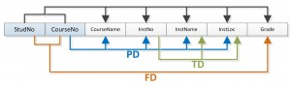*Figure 12.1 Dependency diagram, by A. Watt.*

The abbreviations used in Figure 12.1 are as follows:

* PD: partial dependency
* TD: transitive dependency
* FD: full dependency (Note: FD typically stands for **functional** dependency. Using FD as an abbreviation for full dependency is only used in Figure 12.1.)

## **Boyce-Codd Normal Form (BCNF)**

When a table has more than one candidate key, anomalies may result even though the relation is in 3NF. *Boyce-Codd normal form* is a special case of 3NF. A relation is in BCNF if, and only if, every determinant is a candidate key.

### BCNF Example 1

Consider the following table (**St_Maj_Adv**).

|  |  |  |
| --- | --- | --- |
| **Student_id** | **Major** | **Advisor** |
| 111 | Physics | Smith |
| 111 | Music | Chan |
| 320 | Math | Dobbs |
| 671 | Physics | White |
| 803 | Physics | Smith |

The *semantic rules* (business rules applied to the database) for this table are:

1. Each Student may major in several subjects.
2. For each Major, a given Student has only one Advisor.
3. Each Major has several Advisors.
4. Each Advisor advises only one Major.
5. Each Advisor advises several Students in one Major.

The functional dependencies for this table are listed below. The first one is a candidate key; the second is not.

1. Student_id, Major ——> Advisor
2. Advisor ——> Major

Anomalies for this table include:

1. Delete – student deletes advisor info
2. Insert – a new advisor needs a student
3. Update – inconsistencies

**Note**: No single attribute is a candidate key.

PK can be Student_id, Major or Student_id, Advisor**.**

To reduce the **St_Maj_Adv** relation to BCNF, you create two new tables:

1. **St_Adv** (Student_id, Advisor)
2. **Adv_Maj** (Advisor, Major)

**St_Adv** table

|  |  |
| --- | --- |
| **Student_id** | **Advisor** |
| 111 | Smith |
| 111 | Chan |
| 320 | Dobbs |
| 671 | White |
| 803 | Smith |

**Adv_Maj** table

|  |  |
| --- | --- |
| **Advisor** | **Major** |
| Smith | Physics |
| Chan | Music |
| Dobbs | Math |
| White | Physics |

### BCNF Example 2

Consider the following table (**Client_Interview)**.

|  |  |  |  |  |
| --- | --- | --- | --- | --- |
| **ClientNo** | **InterviewDate** | **InterviewTime** | **StaffNo** | **RoomNo** |
| CR76 | 13-May-02 | 10.30 | SG5 | G101 |
| CR56 | 13-May-02 | 12.00 | SG5 | G101 |
| CR74 | 13-May-02 | 12.00 | SG37 | G102 |
| CR56 | 1-July-02 | 10.30 | SG5 | G102 |

FD1 – ClientNo, InterviewDate –> InterviewTime, StaffNo, RoomNo (PK)

FD2 – staffNo, interviewDate, interviewTime –> clientNO (candidate key: CK)

FD3 – roomNo, interviewDate, interviewTime –> staffNo, clientNo (CK)

FD4 – staffNo, interviewDate –> roomNo

A relation is in BCNF if, and only if, every determinant is a candidate key. We need to create a table that incorporates the first three FDs (**Client_Interview2** table) and another table (**StaffRoom** table) for the fourth FD.

**Client_Interview2** table

|  |  |  |  |
| --- | --- | --- | --- |
| **ClientNo** | **InterviewDate** | **InterViewTime** | **StaffNo** |
| CR76 | 13-May-02 | 10.30 | SG5 |
| CR56 | 13-May-02 | 12.00 | SG5 |
| CR74 | 13-May-02 | 12.00 | SG37 |
| CR56 | 1-July-02 | 10.30 | SG5 |

**StaffRoom** table

|  |  |  |
| --- | --- | --- |
| **StaffNo** | **InterviewDate** | **RoomNo** |
| SG5 | 13-May-02 | G101 |
| SG37 | 13-May-02 | G102 |
| SG5 | 1-July-02 | G102 |

## **Normalization and Database Design**

During the normalization process of database design, make sure that proposed entities meet required normal form before table structures are created. Many real-world databases have been improperly designed or burdened with anomalies if improperly modified during the course of time. You may be asked to redesign and modify existing databases. This can be a large undertaking if the tables are not properly normalized.

## **Boyce-Codd Normal Form (BCNF)**

When a table has more than one candidate key, anomalies may result even though the relation is in 3NF. *Boyce-Codd normal form* is a special case of 3NF. A relation is in BCNF if, and only if, every determinant is a candidate key.

### BCNF Example 1

Consider the following table (**St_Maj_Adv**).

|  |  |  |
| --- | --- | --- |
| **Student_id** | **Major** | **Advisor** |
| 111 | Physics | Smith |
| 111 | Music | Chan |
| 320 | Math | Dobbs |
| 671 | Physics | White |
| 803 | Physics | Smith |

The *semantic rules* (business rules applied to the database) for this table are:

1. Each Student may major in several subjects.
2. For each Major, a given Student has only one Advisor.
3. Each Major has several Advisors.
4. Each Advisor advises only one Major.
5. Each Advisor advises several Students in one Major.

The functional dependencies for this table are listed below. The first one is a candidate key; the second is not.

1. Student_id, Major ——> Advisor
2. Advisor ——> Major

Anomalies for this table include:

1. Delete – student deletes advisor info
2. Insert – a new advisor needs a student
3. Update – inconsistencies

**Note**: No single attribute is a candidate key.

PK can be Student_id, Major or Student_id, Advisor**.**

To reduce the **St_Maj_Adv** relation to BCNF, you create two new tables:

1. **St_Adv** (Student_id, Advisor)
2. **Adv_Maj** (Advisor, Major)

**St_Adv** table

|  |  |
| --- | --- |
| **Student_id** | **Advisor** |
| 111 | Smith |
| 111 | Chan |
| 320 | Dobbs |
| 671 | White |
| 803 | Smith |

**Adv_Maj** table

|  |  |
| --- | --- |
| **Advisor** | **Major** |
| Smith | Physics |
| Chan | Music |
| Dobbs | Math |
| White | Physics |

### BCNF Example 2

Consider the following table (**Client_Interview)**.

|  |  |  |  |  |
| --- | --- | --- | --- | --- |
| **ClientNo** | **InterviewDate** | **InterviewTime** | **StaffNo** | **RoomNo** |
| CR76 | 13-May-02 | 10.30 | SG5 | G101 |
| CR56 | 13-May-02 | 12.00 | SG5 | G101 |
| CR74 | 13-May-02 | 12.00 | SG37 | G102 |
| CR56 | 1-July-02 | 10.30 | SG5 | G102 |

FD1 – ClientNo, InterviewDate –> InterviewTime, StaffNo, RoomNo (PK)

FD2 – staffNo, interviewDate, interviewTime –> clientNO (candidate key: CK)

FD3 – roomNo, interviewDate, interviewTime –> staffNo, clientNo (CK)

FD4 – staffNo, interviewDate –> roomNo

A relation is in BCNF if, and only if, every determinant is a candidate key. We need to create a table that incorporates the first three FDs (**Client_Interview2** table) and another table (**StaffRoom** table) for the fourth FD.

**Client_Interview2** table

|  |  |  |  |
| --- | --- | --- | --- |
| **ClientNo** | **InterviewDate** | **InterViewTime** | **StaffNo** |
| CR76 | 13-May-02 | 10.30 | SG5 |
| CR56 | 13-May-02 | 12.00 | SG5 |
| CR74 | 13-May-02 | 12.00 | SG37 |
| CR56 | 1-July-02 | 10.30 | SG5 |

**StaffRoom** table

|  |  |  |
| --- | --- | --- |
| **StaffNo** | **InterviewDate** | **RoomNo** |
| SG5 | 13-May-02 | G101 |
| SG37 | 13-May-02 | G102 |
| SG5 | 1-July-02 | G102 |

## **Normalization and Database Design**

During the normalization process of database design, make sure that proposed entities meet required normal form before table structures are created. Many real-world databases have been improperly designed or burdened with anomalies if improperly modified during the course of time. You may be asked to redesign and modify existing databases. This can be a large undertaking if the tables are not properly normalized.

## **Normalization Example: The Farmer's Market**



A local farmer's market needs a database system to manage its operations efficiently. Currently, all data is stored in a single, unnormalized table, leading to redundancies and data anomalies. Our task is to design a normalized database structure that eliminates these issues and improves data integrity.

For the farmers market we store vendor, product and market information. Every vendor has a unique ID, and we need to store their name, and phone number. Vendors can sell multiple products and might offer different products on different market days. The market operates on specific dates where the vendors rent stalls on a per-day basis and are assigned a stall number for that day. Stall rental fee and market location vary depending on the market date. Each market location has a fixed location capacity associated with it.

The goal of this exercise is to analyze this unnormalized table and apply the normalization process to achieve Third Normal Form (3NF). The final design should result in a set of normalized tables that maintain data integrity, prevent update anomalies, and allow for efficient management of the farmer's market information.

***Note:*** We use underline to highlight primary keys and asterisk (*) to highlight foreign keys.

**Unnormalized Relation**

 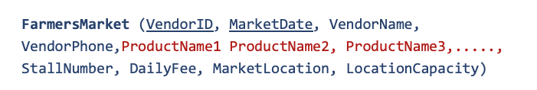

The table is unnormalized because it violates the First Normal Form (1NF) rule. It contains **multi-valued attributes** (Product1, Product2, Product3), which means that all attributes are **not atomic.** These multi-valued attributes create repeating groups within the table.

To achieve First Normal Form (1NF), we need to eliminate the multi-valued attributes by separating the multi-valued attributes into a new table. This process will ensure that all attributes contain only atomic (indivisible) values and that there are no repeating groups.

## **Achieving First Normal Form**



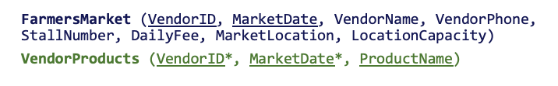

The tables are now in First Normal Form (1NF) because all attributes are atomic and there are no repeating groups or multi-valued attributes.

The multi-valued product attributes have been separated into a new table, VendorProducts. Each row in VendorProducts uniquely identifies a product offered by a specific vendor on a particular date.

Note that the key attributes from the original table (VendorID and MarketDate) are included in the new VendorProducts table as a foreign key, along with the separated attribute (ProductName). This maintains the relationship between the products and the original data.

## **Problems in First Normal Form**



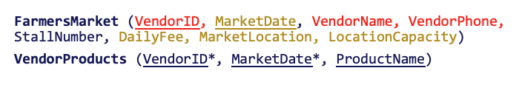

While the tables are in First Normal Form (1NF), the tables still violate the rules for Second Normal Form (2NF) because there are **partial functional dependencies** present.

First, VendorName and VendorPhone depend only on part of the key (VendorID) and not on the full key {VendorID, MarketDate}.

Also, DailyFee, MarketLocation and LocationCapacity depend on part of the key (MarketDate) and not on the full key {VendorID, MarketDate}.To achieve Second Normal Form (2NF), we need to separate the partially dependent attributes into a new relation and keep these attributes with the part of the key they depend on.

## **Achieving Second Normal Form**



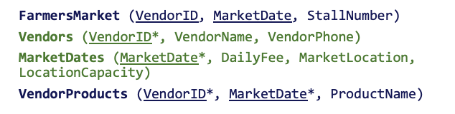

The tables are now in Second Normal Form (1NF) because there are no partial functional dependencies.

The partially dependent attributes (VendorName, VendorPhone) have been moved into a new table Vendors along with the part of key they depend on (VendorID).

The partially dependent attributes (DailyFee, MarketLocation, LocationCapacity) are moved to a new table Vendors along with the part of key they depend on (VendorID).

Here the relationship with original table is maintained by the common attributes (VendorID or MarketDate)

**Problems in Second Normal Form**



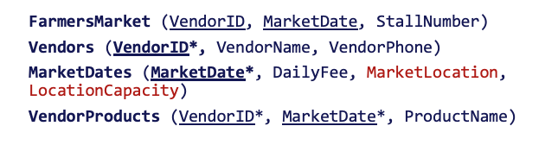

The tables are in Second Normal Form (2NF), but they are not yet in Third Normal Form (3NF) because there is a **transitive functional dependency** violating the rules for 3NF.

LocationCapacity does not directly depend on MarketDate. It depends on MarketLocation, which in turn depends on MarketDate, creating a transitive dependency.

To achieve 3NF, we need to separate the transitively dependent attributes into a new table with the attribute they directly depend on.

**Achieving Third Normal Form**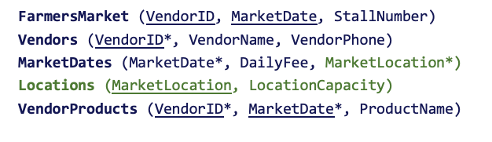

To achieve 3NF tables we separated the transitively dependency attribute LocationCapacity into a new table with the attribute it directly depended on (MarketLocation). MarketLocation becomes the key for the new table and the older table, MarketDate has a foreign key referring to it.

The tables are now completely normalized and in 3NF. This design ensures data integrity, prevents data anomalies, and allows for efficient management of the farmer's market information.

Assignment:

Question 1

In an EER diagram with a many-to-many relationship between "Student" and "Course" entities, how would you represent this in a relational database model?

1. Create a new junction table with foreign keys referencing both Student and Course tables

**1 point**

### **2.**

Question 2

Which normal form eliminates transitive dependencies in a relational database?

1. Third Normal Form (3NF)

**1 point**

### **3.**

Question 3

A table contains: OrderID, CustomerName, ProductID, ProductName, Quantity, and CustomerAddress. OrderID is the primary key of this table.

Which normal form does this table violate, and why?

1. 3NF, because it has a transitive dependency

**1 point**

### **4.**

Question 4

Consider this relation for a library:

Book(BookID, Title, Author, AuthorEmail, Genre)

Where BookID is the primary key. Which of the following represents the correct normalization to 3NF?

1. Book(BookID, Title, Author, Genre)

Author(Author, AuthorEmail)

SQL

*Structured Query Language* (SQL) is a database language designed for managing data held in a relational database management system. SQL was initially developed by IBM in the early 1970s (Date 1986). The initial version, called *SEQUEL* (Structured English Query Language), was designed to manipulate and retrieve data stored in IBM’s quasi-relational database management system, System R. Then in the late 1970s, Relational Software Inc., which is now Oracle Corporation, introduced the first commercially available implementation of SQL, Oracle V2 for VAX computers.

Many of the currently available relational DBMSs, such as Oracle Database, Microsoft SQL Server (shown in Figure 15.1), MySQL, IBM DB2, IBM Informix and Microsoft Access, use SQL.

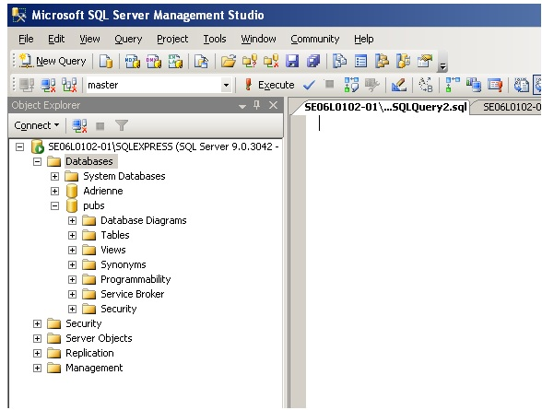

*Figure 15.1. Example of Microsoft SQL Server, by A. Watt.*

In a DBMS, the SQL database language is used to:

* Create the database and table structures
* Perform basic data management chores (add, delete and modify)
* Perform complex queries to transform raw data into useful information

In this chapter, we will focus on using SQL to create the database and table structures, mainly using SQL as a data definition language (*DDL*). In Chapter 16, we will use SQL as a data manipulation language (*DML*) to insert, delete, select and update data within the database tables.

## **Create Database**

The major SQL DDL statements are CREATE DATABASE and CREATE/DROP/ALTER TABLE. The SQL statement CREATE is used to create the database and table structures.

**Example: CREATE DATABASE SW**

A new database named **SW** is created by the SQL statement CREATE DATABASE SW. Once the database is created, the next step is to create the database tables.

The general format for the CREATE TABLE command is:

CREATE TABLE <tablename>  
(  
ColumnName, Datatype, Optional Column Constraint,  
ColumnName, Datatype, Optional Column Constraint,  
Optional table Constraints  
);

Tablename is the name of the database table such as **Employee**. Each field in the CREATE TABLE has three parts (see above):

1. ColumnName
2. Data type
3. Optional Column Constraint

### ColumnName

The ColumnName must be unique within the table. Some examples of ColumnNames are FirstName and LastName.

## **Data Type**

The data type, as described below, must be a system data type or a user-defined data type. Many of the data types have a size such as CHAR(35) or Numeric(8,2).

**Bit** **–**Integer data with either a 1 or 0 value

**Int –**Integer (whole number) data from -2^31 (-2,147,483,648) through 2^31 – 1 (2,147,483,647)

**Smallint –**Integer data from 2^15 (-32,768) through 2^15 – 1 (32,767)

**Tinyint** **–**Integer data from 0 through 255

**Decimal –**Fixed precision and scale numeric data from -10^38 -1 through 10^38

**Numeric –**A synonym for **decimal**

**Timestamp –**A database-wide unique number

**Uniqueidentifier –**A globally unique identifier (GUID)

**Money** – Monetary data values from -2^63 (-922,337,203,685,477.5808) through 2^63 – 1 (+922,337,203,685,477.5807), with accuracy to one-ten-thousandth of a monetary unit

**Smallmoney –**Monetary data values from -214,748.3648 through +214,748.3647, with accuracy to one-ten-thousandth of a monetary unit

**Float –**Floating precision number data from -1.79E + 308 through 1.79E + 308

**Real –**Floating precision number data from -3.40E + 38 through 3.40E + 38

**Datetime –**Date and time data from January 1, 1753, to December 31, 9999, with an accuracy of one-three-hundredths of a second, or 3.33 milliseconds

**Smalldatetime –**Date and time data from January 1, 1900, through June 6, 2079, with an accuracy of one minute

**Char –**Fixed-length non-Unicode character data with a maximum length of 8,000 characters

**Varchar –**Variable-length non-Unicode data with a maximum of 8,000 characters

**Text –**Variable-length non-Unicode data with a maximum length of 2^31 – 1 (2,147,483,647) characters

**Binary –**Fixed-length binary data with a maximum length of 8,000 bytes

**Varbinary –**Variable-length binary data with a maximum length of 8,000 bytes

**Image –** Variable-length binary data with a maximum length of 2^31 – 1 (2,147,483,647) bytes

## **Optional Column Constraints**

The Optional ColumnConstraints are NULL, NOT NULL, UNIQUE, PRIMARY KEY and DEFAULT, used to initialize a value for a new record. The column constraint NULL indicates that null values are allowed, which means that a row can be created without a value for this column. The column constraint NOT NULL indicates that a value must be supplied when a new row is created.

To illustrate, we will use the SQL statement CREATE TABLE EMPLOYEES to create the employees table with 16 attributes or fields.

USE SW  
CREATE TABLE EMPLOYEES  
(  
EmployeeNo CHAR(10) NOT NULL UNIQUE,  
DepartmentName CHAR(30) NOT NULL DEFAULT “Human Resources”,  
FirstName CHAR(25) NOT NULL,  
LastName CHAR(25) NOT NULL,  
Category CHAR(20) NOT NULL,  
HourlyRate CURRENCY NOT NULL,  
TimeCard LOGICAL NOT NULL,  
HourlySalaried CHAR(1) NOT NULL,  
EmpType CHAR(1) NOT NULL,  
Terminated LOGICAL NOT NULL,  
ExemptCode CHAR(2) NOT NULL,  
Supervisor LOGICAL NOT NULL,  
SupervisorName CHAR(50) NOT NULL,  
BirthDate DATE NOT NULL,  
CollegeDegree CHAR(5) NOT NULL,  
CONSTRAINT Employee_PK PRIMARY KEY(EmployeeNo  
);

The first field is EmployeeNo with a field type of CHAR. For this field, the field length is 10 characters, and the user cannot leave this field empty (NOT NULL).

Similarly, the second field is DepartmentName with a field type CHAR of length 30. After all the table columns are defined, a table constraint, identified by the word CONSTRAINT, is used to create the primary key:

CONSTRAINT EmployeePK PRIMARY KEY(EmployeeNo)

We will discuss the constraint property further later in this chapter.

Likewise, we can create a Department table, a Project table and an Assignment table using the CREATE TABLE SQL DDL command as shown in the below example.

USE SW  
CREATE TABLE DEPARTMENT  
(  
DepartmentName Char(35) NOT NULL,  
BudgetCode Char(30) NOT NULL,  
OfficeNumber Char(15) NOT NULL,  
Phone Char(15) NOT NULL,  
CONSTRAINT DEPARTMENT_PK PRIMARY KEY(DepartmentName)  
);

In this example, a project table is created with seven fields: ProjectID, ProjectName, Department, MaxHours, StartDate, and EndDate.

USE SW  
CREATE TABLE PROJECT  
(  
ProjectID Int NOT NULL IDENTITY (1000,100),  
ProjectName Char(50) NOT NULL,  
Department Char(35) NOT NULL,  
MaxHours Numeric(8,2) NOT NULL DEFAULT 100,  
StartDate DateTime NULL,  
EndDate DateTime NULL,  
CONSTRAINT ASSIGNMENT_PK PRIMARY KEY(ProjectID)  
);

In this last example, an assignment table is created with three fields: ProjectID, EmployeeNumber, and HoursWorked. The assignment table is used to record who (EmployeeNumber) and how much time(HoursWorked) an employee worked on the particular project(ProjectID).

USE SW  
CREATE TABLE ASSIGNMENT  
(  
ProjectID Int NOT NULL,  
EmployeeNumber Int NOT NULL,  
HoursWorked Numeric(6,2) NULL,  
);

## **Table Constraints**

Table constraints are identified by the CONSTRAINT keyword and can be used to implement various constraints described below.

### IDENTITY constraint

We can use the optional column constraint IDENTITY to provide a unique, incremental value for that column. Identity columns are often used with the PRIMARY KEY constraints to serve as the unique row identifier for the table. The IDENTITY property can be assigned to a column with a tinyint, smallint, int, decimal or numeric data type. This constraint:

* Generates sequential numbers
* Does not enforce entity integrity
* Only one column can have the IDENTITY property
* Must be defined as an integer, numeric or decimal data type
* Cannot update a column with the IDENTITY property
* Cannot contain NULL values
* Cannot bind defaults and default constraints to the column

For IDENTITY[(seed, increment)]

* Seed – the initial value of the identity column
* Increment – the value to add to the last increment column

We will use another database example to further illustrate the SQL DDL statements by creating the table tblHotel in this HOTEL database.

CREATE TABLE tblHotel  
(  
HotelNo Int IDENTITY (1,1),  
Name Char(50) NOT NULL,  
Address Char(50) NULL,  
City Char(25) NULL,  
)

UNIQUE constraint

The UNIQUE constraint prevents duplicate values from being entered into a column.

* Both PK and UNIQUE constraints are used to enforce entity integrity.
* Multiple UNIQUE constraints can be defined for a table.
* When a UNIQUE constraint is added to an existing table, the existing data is always validated.
* A UNIQUE constraint can be placed on columns that accept nulls. *Only one row can be NULL.*
* A UNIQUE constraint automatically creates a unique index on the selected column.

This is the general syntax for the UNIQUE constraint:

[CONSTRAINT constraint_name]  
UNIQUE [CLUSTERED | NONCLUSTERED]  
(col_name [, col_name2 […, col_name16]])  
[ON segment_name]

This is an examle using the UNIQUE constraint.

CREATE TABLE EMPLOYEES  
(  
EmployeeNo CHAR(10) NOT NULL UNIQUE,  
)

### FOREIGN KEY constraint

The FOREIGN KEY (FK) constraint defines a column, or combination of columns, whose values match the PRIMARY KEY (PK) of another table.

* Values in an FK are automatically updated when the PK values in the associated table are updated/changed.
* FK constraints must reference PK or the UNIQUE constraint of another table.
* The number of columns for FK must be same as PK or UNIQUE constraint.
* If the WITH NOCHECK option is used, the FK constraint will not validate existing data in a table.
* No index is created on the columns that participate in an FK constraint.

This is the general syntax for the FOREIGN KEY constraint:

[CONSTRAINT constraint_name]  
[FOREIGN KEY (col_name [, col_name2 […, col_name16]])]  
REFERENCES [owner.]ref_table [(ref_col [, ref_col2 […, ref_col16]])]

In this example, the field HotelNo in the tblRoom table is a FK to the field HotelNo in the tblHotel table shown previously.

USE HOTEL  
GO  
CREATE TABLE tblRoom  
(  
HotelNo Int NOT NULL ,  
RoomNo Int NOT NULL,  
Type Char(50) NULL,  
Price Money NULL,  
PRIMARY KEY (HotelNo, RoomNo),  
FOREIGN KEY (HotelNo) REFERENCES tblHotel  
)

### CHECK constraint

The CHECK constraint restricts values that can be entered into a table.

* It can contain search conditions similar to a WHERE clause.
* It can reference columns in the same table.
* The data validation rule for a CHECK constraint must evaluate to a boolean expression.
* It can be defined for a column that has a rule bound to it.

This is the general syntax for the CHECK constraint:

[CONSTRAINT constraint_name]  
CHECK [NOT FOR REPLICATION] (expression)

In this example, the Type field is restricted to have only the types ‘Single’, ‘Double’, ‘Suite’ or ‘Executive’.

USE HOTEL  
GO  
CREATE TABLE tblRoom  
(  
HotelNo Int NOT NULL,  
RoomNo Int NOT NULL,  
Type Char(50) NULL,  
Price Money NULL,  
PRIMARY KEY (HotelNo, RoomNo),  
FOREIGN KEY (HotelNo) REFERENCES tblHotel  
CONSTRAINT Valid_Type  
CHECK (Type IN (‘Single’, ‘Double’, ‘Suite’, ‘Executive’))  
)

In this second example, the employee hire date should be before January 1, 2004, or have a salary limit of $300,000.

GO  
CREATE TABLE SALESREPS  
(  
Empl_num Int Not Null  
CHECK (Empl_num BETWEEN 101 and 199),  
Name Char (15),  
Age Int CHECK (Age >= 21),  
Quota Money CHECK (Quota >= 0.0),  
HireDate DateTime,  
CONSTRAINT QuotaCap CHECK ((HireDate < “01-01-2004”) OR (Quota <=300000))  
)

### DEFAULT constraint

The DEFAULT constraint is used to supply a value that is automatically added for a column if the user does not supply one.

* A column can have only one DEFAULT.
* The DEFAULT constraint cannot be used on columns with a timestamp data type or identity property.
* DEFAULT constraints are automatically bound to a column when they are created.

The general syntax for the DEFAULT constraint is:

[CONSTRAINT constraint_name]  
DEFAULT {constant_expression | niladic-function | NULL}  
[FOR col_name]

This example sets the default for the city field to ‘Vancouver’.

USE HOTEL  
ALTER TABLE tblHotel  
Add CONSTRAINT df_city DEFAULT ‘Vancouver’ FOR City

## **User Defined Types**

User defined types are always based on system-supplied data type. They can enforce data integrity and they allow nulls.

To create a user-defined data type in SQL Server, choose types under “Programmability” in your database. Next, right click and choose ‘New’ –>‘User-defined data type’ or execute the sp_addtype system stored procedure. After this, type:

sp_addtype ssn, ‘varchar(11)’, ‘NOT NULL’

This will add a new user-defined data type called SIN with nine characters.

In this example, the field EmployeeSIN uses the user-defined data type SIN.

CREATE TABLE SINTable  
(  
EmployeeID INT Primary Key,  
EmployeeSIN SIN,  
CONSTRAINT CheckSIN  
CHECK (EmployeeSIN LIKE  
‘ [0-9][0-9][0-9] – [0-9][0-9] [0-9] – [0-9][0-9][0-9] ‘)  
)

### ALTER TABLE

You can use ALTER TABLE statements to add and drop constraints.

* ALTER TABLE allows columns to be removed.
* When a constraint is added, all existing data are verified for violations.

In this example, we use the ALTER TABLE statement to the IDENTITY property to a ColumnName field.

USE HOTEL  
GO  
ALTER TABLE tblHotel  
ADD CONSTRAINT unqName UNIQUE (Name)

Use the ALTER TABLE statement to add a column with the IDENTITY property such as ALTER TABLE TableName.

ADD  
ColumnName int IDENTITY(seed, increment)

### DROP TABLE

The DROP TABLE will remove a table from the database. Make sure you have the correct database selected.

DROP TABLE tblHotel

Executing the above SQL DROP TABLE statement will remove the table tblHotel from the database.

The SQL data manipulation language (DML) is used to query and modify database data. In this chapter, we will describe how to use the SELECT, INSERT, UPDATE, and DELETE SQL DML command statements, defined below.

* *SELECT* – to query data in the database
* *INSERT* – to insert data into a table
* *UPDATE* – to update data in a table
* *DELETE* – to delete data from a table

In the SQL DML statement:

* Each clause in a statement should begin on a new line.
* The beginning of each clause should line up with the beginning of other clauses.
* If a clause has several parts, they should appear on separate lines and be indented under the start of the clause to show the relationship.
* Upper case letters are used to represent reserved words.
* Lower case letters are used to represent user-defined words.

# **SELECT Statement**

The SELECT statement, or command, allows the user to extract data from tables, based on specific criteria. It is processed according to the following sequence:

SELECT DISTINCT item(s)  
FROM table(s)  
WHERE predicate  
GROUP BY field(s)  
ORDER BY fields

We can use the SELECT statement to generate an employee phone list from the Employees table as follows:

SELECT FirstName, LastName, phone  
FROM Employees  
ORDER BY LastName

This action will display employee’s last name, first name, and phone number from the Employees table, seen in Table 16.1.

|  |  |  |
| --- | --- | --- |
| **Last Name** | **First Name** | **Phone Number** |
| Hagans | Jim | 604-232-3232 |
| Wong | Bruce | 604-244-2322 |

*Table 16.1. Employees table.*

In this next example, we will use a Publishers table (Table 16.2). (You will notice that Canada is mispelled in the *Publisher Country* field for Example Publishing and ABC Publishing. To correct mispelling, use the UPDATE statement to standardize the country field to Canada – see UPDATE statement later in this chapter.)

|  |  |  |  |
| --- | --- | --- | --- |
| **Publisher Name** | **Publisher City** | **Publisher Province** | **Publisher Country** |
| Acme Publishing | Vancouver | BC | Canada |
| Example Publishing | Edmonton | AB | Cnada |
| ABC Publishing | Toronto | ON | Canda |

*Table 16.2. Publishers table.*

If you add the publisher’s name and city, you would use the SELECT statement followed by the fields name separated by a comma:

SELECT PubName, city  
FROM Publishers

This action will display the publisher’s name and city from the Publishers table.

If you just want the publisher’s name under the display name city, you would use the SELECT statement with *no comma* separating pub_name and city:

SELECT PubName city  
FROM Publishers

Performing this action will display only the pub_name from the Publishers table with a “city” heading. If you do not include the comma, SQL Server assumes you want a new column name for pub_name.

## **SELECT statement with WHERE criteria**

Sometimes you might want to focus on a portion of the Publishers table, such as only publishers that are in Vancouver. In this situation, you would use the SELECT statement with the WHERE criterion, i.e., WHERE city = ‘Vancouver’.

These first two examples illustrate how to limit record selection with the WHERE criterion using BETWEEN. Each of these examples give the same results for store items with between 20 and 50 items in stock.

Example #1 uses the quantity, *qty BETWEEN 20 and 50*.

SELECT StorID, qty, TitleID  
FROM Sales  
WHERE qty BETWEEN 20 and 50 *(includes the 20 and 50)*

Example #2, on the other hand, uses *qty >=20 and qty <=50* .

SELECT StorID, qty, TitleID  
FROM Sales  
WHERE qty >= 20 and qty <= 50

Example #3 illustrates how to limit record selection with the WHERE criterion using NOT BETWEEN.

SELECT StorID, qty, TitleID  
FROM Sales  
WHERE qty NOT BETWEEN 20 and 50

The next two examples show two different ways to limit record selection with the WHERE criterion using IN, with each yielding the same results.

Example #4 shows how to select records using *province=* as part of the WHERE statement.

SELECT *  
FROM Publishers  
WHERE province = ‘BC’ OR province = ‘AB’ OR province = ‘ON’

Example #5 select records using *province IN* as part of the WHERE statement.

SELECT *  
FROM Publishers  
WHERE province IN (‘BC’, ‘AB’, ‘ON’)

The final two examples illustrate how NULL and NOT NULL can be used to select records. For these examples, a Books table (not shown) would be used that contains fields called Title, Quantity, and Price (of book). Each publisher has a Books table that lists all of its books.

Example #6 uses NULL.

SELECT price, title  
FROM Books  
WHERE price IS NULL

Example #7 uses NOT NULL.

SELECT price, title  
FROM Books  
WHERE price IS NOT NULL

## **Using wildcards in the LIKE clause**

The LIKE keyword selects rows containing fields that match specified portions of character strings. LIKE is used with char, varchar, text, datetime and smalldatetime data. A *wildcard* allows the user to match fields that contain certain letters. For example, the wildcard province = ‘N%’ would give all provinces that start with the letter ‘N’. Table 16.3 shows four ways to specify wildcards in the SELECT statement in regular express format.

|  |  |
| --- | --- |
| % | Any string of zero or more characters |
| _ | Any single character |
| [ ] | Any single character within the specified range (e.g., [a-f]) or set (e.g., [abcdef]) |
| [^] | Any single character not within the specified range (e.g., [^a – f]) or set (e.g., [^abcdef]) |

*Table 16.3. How to specify wildcards in the SELECT statement.*

In example #1, LIKE ‘Mc%’ searches for all last names that begin with the letters “Mc” (e.g., McBadden).

SELECT LastName  
FROM Employees  
WHERE LastName LIKE ‘Mc%’

For example #2: LIKE ‘%inger’ searches for all last names that end with the letters “inger” (e.g., Ringer, Stringer).

SELECT LastName  
FROM Employees  
WHERE LastName LIKE ‘%inger’

In, example #3: LIKE ‘%en%’ searches for all last names that have the letters “en” (e.g., Bennett, Green, McBadden).

SELECT LastName  
FROM Employees  
WHERE LastName LIKE ‘%en%’

## **SELECT statement with ORDER BY clause**

You use the ORDER BY clause to sort the records in the resulting list. Use *ASC* to sort the results in ascending order and *DESC* to sort the results in descending order.

For example, with ASC:

SELECT *  
FROM Employees  
ORDER BY HireDate ASC

And with DESC:

SELECT *  
FROM Books  
ORDER BY type, price DESC

## **SELECT statement with GROUP BY clause**

The *GROUP BY* clause is used to create one output row per each group and produces summary values for the selected columns, as shown below.

SELECT type  
FROM Books  
GROUP BY type

Here is an example using the above statement.

SELECT type AS ‘Type’, MIN(price) AS ‘Minimum Price’  
FROM Books  
WHERE royalty > 10  
GROUP BY type

If the SELECT statement includes a WHERE criterion where *price is not null*,

SELECT type, price  
FROM Books  
WHERE price is not null

then a statement with the GROUP BY clause would look like this:

SELECT type AS ‘Type’, MIN(price) AS ‘Minimum Price’  
FROM Books  
WHERE price is not null  
GROUP BY type

### Using COUNT with GROUP BY

We can use COUNT to tally how many items are in a container. However, if we want to count different items into separate groups, such as marbles of varying colours, then we would use the COUNT function with the GROUP BY command.

The below SELECT statement illustrates how to count groups of data using the COUNT function with the GROUP BY clause.

SELECT COUNT(*)  
FROM Books  
GROUP BY type

### Using AVG and SUM with GROUP BY

We can use the AVG function to give us the average of any group, and SUM to give the total.

Example #1 uses the AVG FUNCTION with the GROUP BY type.

SELECT AVG(qty)  
FROM Books  
GROUP BY type

Example #2 uses the SUM function with the GROUP BY type.

SELECT SUM(qty)  
FROM Books  
GROUP BY type

Example #3 uses both the AVG and SUM functions with the GROUP BY type in the SELECT statement.

SELECT ‘Total Sales’ = SUM(qty), ‘Average Sales’ = AVG(qty), stor_id  
FROM Sales  
GROUP BY StorID ORDER BY ‘Total Sales’

## **Restricting rows with HAVING**

The HAVING clause can be used to restrict rows. It is similar to the WHERE condition except HAVING can include the aggregate function; the WHERE cannot do this.

The HAVING clause behaves like the WHERE clause, but is applicable to groups. In this example, we use the HAVING clause to exclude the groups with the province ‘BC’.

SELECT au_fname AS ‘Author”s First Name’, province as ‘Province’  
FROM Authors  
GROUP BY au_fname, province  
HAVING province <> ‘BC’

## **INSERT statement**

The *INSERT statement* adds rows to a table. In addition,

* INSERT specifies the table or view that data will be inserted into.
* Column_list lists columns that will be affected by the INSERT.
* If a column is omitted, each value must be provided.
* If you are including columns, they can be listed in any order.
* VALUES specifies the data that you want to insert into the table. VALUES is required.
* Columns with the IDENTITY property should not be explicitly listed in the column_list or values_clause.

The syntax for the INSERT statement is:

INSERT [INTO] Table_name | view name [column_list]  
DEFAULT VALUES | values_list | select statement

When inserting rows with the INSERT statement, these rules apply:

* Inserting an empty string (‘ ‘) into a varchar or text column inserts a single space.
* All char columns are right-padded to the defined length.
* All trailing spaces are removed from data inserted into varchar columns, except in strings that contain only spaces. These strings are truncated to a single space.
* If an INSERT statement violates a constraint, default or rule, or if it is the wrong data type, the statement fails and SQL Server displays an error message.

When you specify values for only some of the columns in the column_list, one of three things can happen to the columns that have no values:

1. A default value is entered if the column has a DEFAULT constraint, if a default is bound to the column, or if a default is bound to the underlying user-defined data type.
2. NULL is entered if the column allows NULLs and no default value exists for the column.
3. An error message is displayed and the row is rejected if the column is defined as NOT NULL and no default exists.

This example uses INSERT to add a record to the publisher’s Authors table.

INSERT INTO Authors  
VALUES(‘555-093-467’, ‘Martin’, ‘April’, ‘281 555-5673’, ‘816 Market St.,’ , ‘Vancouver’, ‘BC’, ‘V7G3P4’, 0)

This following example illustrates how to insert a partial row into the Publishers table with a column list. The country column had a default value of Canada so it does not require that you include it in your values.

INSERT INTO Publishers (PubID, PubName, city, province)  
VALUES (‘9900’, ‘Acme Publishing’, ‘Vancouver’, ‘BC’)

To insert rows into a table with an IDENTITY column, follow the below example. Do not supply the value for the IDENTITY nor the name of the column in the column list.

INSERT INTO jobs  
VALUES (‘DBA’, 100, 175)

### Inserting specific values into an IDENTITY column

By default, data cannot be inserted directly into an IDENTITY column; however, if a row is accidentally deleted, or there are gaps in the IDENTITY column values, you can insert a row and specify the IDENTITY column value.

IDENTITY_INSERT option

To allow an insert with a specific identity value, the IDENTITY_INSERT option can be used as follows.

SET IDENTITY_INSERT jobs ON  
INSERT INTO jobs (job_id, job_desc, min_lvl, max_lvl)  
VALUES (19, ’DBA2’, 100, 175)  
SET IDENTITY_INSERT jobs OFF

### Inserting rows with a SELECT statement

We can sometimes create a small temporary table from a large table. For this, we can insert rows with a SELECT statement. When using this command, there is no validation for uniqueness. Consequently, there may be many rows with the same pub_id in the example below.

This example creates a smaller temporary Publishers table using the CREATE TABLE statement. Then the INSERT with a SELECT statement is used to add records to this temporary Publishers table from the publis table.

CREATE TABLE dbo.tmpPublishers (  
PubID char (4) NOT NULL ,  
PubName varchar (40) NULL ,  
city varchar (20) NULL ,  
province char (2) NULL ,  
country varchar (30) NULL DEFAULT (‘Canada’)  
)  
INSERT tmpPublishers  
SELECT * FROM Publishers

In this example, we’re copying a subset of data.

INSERT tmpPublishers (pub_id, pub_name)  
SELECT PubID, PubName  
FROM Publishers

In this example, the publishers’ data are copied to the tmpPublishers table and the country column is set to Canada.

INSERT tmpPublishers (PubID, PubName, city, province, country)  
SELECT PubID, PubName, city, province, ‘Canada’  
FROM Publishers

## **UPDATE statement**

The *UPDATE statement* changes data in existing rows either by adding new data or modifying existing data.

This example uses the UPDATE statement to standardize the country field to be Canada for all records in the Publishers table.

UPDATE Publishers  
SET country = ‘Canada’

This example increases the royalty amount by 10% for those royalty amounts between 10 and 20.

UPDATE roysched  
SET royalty = royalty + (royalty * .10)  
WHERE royalty BETWEEN 10 and 20

### Including subqueries in an UPDATE statement

The employees from the Employees table who were hired by the publisher in 2010 are given a promotion to the highest job level for their job type. This is what the UPDATE statement would look like.

UPDATE Employees  
SET job_lvl =  
(SELECT max_lvl FROM jobs  
WHERE employee.job_id = jobs.job_id)  
WHERE DATEPART(year, employee.hire_date) = 2010

## **DELETE statement**

The *DELETE statement* removes rows from a record set. DELETE names the table or view that holds the rows that will be deleted and only one table or row may be listed at a time. WHERE is a standard WHERE clause that limits the deletion to select records.

The DELETE syntax looks like this.

DELETE [FROM] {table_name | view_name }  
[WHERE clause]

The rules for the DELETE statement are:

1. If you omit a WHERE clause, all rows in the table are removed (except for indexes, the table, constraints)*.*
2. DELETE cannot be used with a view that has a FROM clause naming more than one table. (Delete can affect only one base table at a time.)

What follows are three different DELETE statements that can be used.

1. Deleting all rows from a table.

DELETE  
FROM Discounts

2. Deleting selected rows:

DELETE  
FROM Sales  
WHERE stor_id = ‘6380’

3. Deleting rows based on a value in a subquery:

DELETE FROM Sales  
WHERE title_id IN  
(SELECT title_id FROM Books WHERE type = ‘mod_cook’)

# **Built-in Functions**

There are many built-in functions in SQL Server such as:

1. *Aggregate:* returns summary values
2. *Conversion:* transforms one data type to another
3. *Date:* displays information about dates and times
4. *Mathematical:* performs operations on numeric data
5. *String:* performs operations on character strings, binary data or expressions
6. *System:* returns a special piece of information from the database
7. *Text and image:* performs operations on text and image data

Below you will find detailed descriptions and examples for the first four functions.

## **Aggregate functions**

Aggregate functions perform a calculation on a set of values and return a single, or summary, value. Table 16.4 lists these functions.

|  |  |
| --- | --- |
| **FUNCTION** | **DESCRIPTION** |
| AVG | Returns the average of all the values, or only the DISTINCT values, in the expression. |
| COUNT | Returns the number of non-null values in the expression. When DISTINCT is specified, COUNT finds the number of unique non-null values. |
| COUNT(*) | Returns the number of rows. COUNT(*) takes no parameters and cannot be used with DISTINCT. |
| MAX | Returns the maximum value in the expression. MAX can be used with numeric, character and datetime columns, but not with bit columns. With character columns, MAX finds the highest value in the collating sequence. MAX ignores any null values. |
| MIN | Returns the minimum value in the expression. MIN can be used with numeric, character and datetime columns, but not with bit columns. With character columns, MIN finds the value that is lowest in the sort sequence. MIN ignores any null values. |
| SUM | Returns the sum of all the values, or only the DISTINCT values, in the expression. SUM can be used with numeric columns only. |

*Table 16.4 A list of aggregate functions and descriptions.*

Below are examples of each of the aggregate functions listed in Table 16.4.

**Example #1: AVG**

SELECT AVG (price) AS ‘Average Title Price’  
FROM Books

**Example #2: COUNT**

SELECT COUNT(PubID) AS ‘Number of Publishers’  
FROM Publishers

**Example #3: COUNT**

SELECT COUNT(province) AS ‘Number of Publishers’  
FROM Publishers

**Example #3: COUNT (*)**

SELECT COUNT(*)  
FROM Employees  
WHERE job_lvl = 35

**Example #4: MAX**

SELECT MAX (HireDate)  
FROM Employees

**Example #5: MIN**

SELECT MIN (price)  
FROM Books

**Example #6: SUM**

SELECT SUM(discount) AS ‘Total Discounts’  
FROM Discounts

## **Conversion function**

The conversion function transforms one data type to another.

In the example below, a price that contains two 9s is converted into five characters. The syntax for this statement is SELECT ‘The date is ‘ + CONVERT(varchar(12), getdate()).

SELECT CONVERT(int, 10.6496)  
SELECT title_id, price  
FROM Books  
WHERE CONVERT(char(5), price) LIKE ‘%99%’

In this second example, the conversion function changes data to a data type with a different size.

SELECT title_id, CONVERT(char(4), ytd_sales) as ‘Sales’  
FROM Books  
WHERE type LIKE ‘%cook’

## **Date function**

The date function produces a date by adding an interval to a specified date. The result is a datetime value equal to the date plus the number of date parts. If the date parameter is a smalldatetime value, the result is also a smalldatetime value.

The DATEADD function is used to add and increment date values. The syntax for this function is DATEADD(datepart, number, date).

SELECT DATEADD(day, 3, hire_date)  
FROM Employees

In this example, the function DATEDIFF(datepart, date1, date2) is used.

This command returns the number of datepart “boundaries” crossed between two specified dates. The method of counting crossed boundaries makes the result given by DATEDIFF consistent across all data types such as minutes, seconds, and milliseconds.

SELECT DATEDIFF(day, HireDate, ‘Nov 30 1995’)  
FROM Employees

For any particular date, we can examine any part of that date from the year to the millisecond.

The date parts (DATEPART) and abbreviations recognized by SQL Server, and the acceptable values are listed in Table 16.5.

|  |  |  |
| --- | --- | --- |
| **DATE PART** | **ABBREVIATION** | **VALUES** |
| Year | yy | 1753-9999 |
| Quarter | qq | 1-4 |
| Month | mm | 1-12 |
| Day of year | dy | 1-366 |
| Day | dd | 1-31 |
| Week | wk | 1-53 |
| Weekday | dw | 1-7 (Sun.-Sat.) |
| Hour | hh | 0-23 |
| Minute | mi | 0-59 |
| Second | ss | 0-59 |
| Millisecond | ms | 0-999 |

*Table 16.5. Date part abbreviations and values.*

## **Mathematical functions**

Mathematical functions perform operations on numeric data. The following example lists the current price for each book sold by the publisher and what they would be if all prices increased by 10%.

SELECT Price, (price * 1.1) AS ‘New Price’, title  
FROM Books  
SELECT ‘Square Root’ = SQRT(81)  
SELECT ‘Rounded‘ = ROUND(4567.9876,2)  
SELECT FLOOR (123.45)

# **Joining Tables**

Joining two or more tables is the process of comparing the data in specified columns and using the comparison results to form a new table from the rows that qualify. A join statement:

* Specifies a column from each table
* Compares the values in those columns row by row
* Combines rows with qualifying values into a new row

Although the comparison is usually for equality – values that match exactly – other types of joins can also be specified. All the different joins such as inner, left (outer), right (outer), and cross join will be described below.

## **Inner join**

An *inner join* connects two tables on a column with the same data type. Only the rows where the column values match are returned; unmatched rows are discarded.

**Example #1**

SELECT jobs.job_id, job_desc  
FROM jobs  
INNER JOIN Employees ON employee.job_id = jobs.job_id  
WHERE jobs.job_id < 7

**Example #2**

SELECT authors.au_fname, authors.au_lname, books.royalty, title  
FROM authorsINNER JOIN titleauthor ON authors.au_id=titleauthor.au_id  
INNER JOIN books ON titleauthor.title_id=books.title_id  
GROUP BY authors.au_lname, authors.au_fname, title, title.royalty  
ORDER BY authors.au_lname

## **Left outer join**

A *left outer join* specifies that all left outer rows be returned. All rows from the left table that did not meet the condition specified are included in the results set, and output columns from the other table are set to NULL.

This first example uses the new syntax for a left outer join.

SELECT publishers.pub_name, books.title  
FROM Publishers  
LEFT OUTER JOIN Books On publishers.pub_id = books.pub_id

This is an example of a left outer join using the old syntax.

SELECT publishers.pub_name, books.title  
FROM Publishers, Books  
WHERE publishers.pub_id *= books.pub_id

## **Right outer join**

A *right outer join* includes, in its result set, all rows from the right table that did not meet the condition specified. Output columns that correspond to the other table are set to NULL.

Below is an example using the new syntax for a right outer join.

SELECT titleauthor.title_id, authors.au_lname, authors.au_fname  
FROM titleauthor  
RIGHT OUTER JOIN authors ON titleauthor.au_id = authors.au_id  
ORDERY BY au_lname

This second example show the old syntax used for a right outer join.

SELECT titleauthor.title_id, authors.au_lname, authors.au_fname  
FROM titleauthor, authors  
WHERE titleauthor.au_id =* authors.au_id  
ORDERY BY au_lname

## **Full outer join**

A *full outer join* specifies that if a row from either table does not match the selection criteria, the row is included in the result set, and its output columns that correspond to the other table are set to NULL.

Here is an example of a full outer join.

SELECT books.title, publishers.pub_name, publishers.province  
FROM Publishers  
FULL OUTER JOIN Books ON books.pub_id = publishers.pub_id  
WHERE (publishers.province <> “BC” and publishers.province <> “ON”)  
ORDER BY books.title_id

## **Cross join**

A *cross join* is a product combining two tables. This join returns the same rows as if no WHERE clause were specified. For example:

SELECT au_lname, pub_name,  
FROM Authors CROSS JOIN Publishers

# **MultiDimensional Data Model**

A Multidimensional Data Model (MDM) organizes data into multiple dimensions such as time, product, location to support fast analytical queries in data warehouses and OLAP systems.

### **Key Features of the Multidimensional Data Model**

* Supports Multi-Dimensional Analysis: Enables users to analyze data across several dimensions (e.g., sales by product, region, and time) to identify business patterns and trends.
* Used in OLAP and Data Warehousing: Forms the foundation of OLAP systems, where data is stored in multidimensional structures for rapid aggregation and reporting.
* Data Cubes: Represents data as cubes that allow viewing information from different perspectives and performing complex analytical operations efficiently.
* Facts: Numerical measures (e.g., sales, revenue). Stored in a fact table.
* Dimensions: Descriptive attributes (e.g., product, region, customer). Stored in dimension tables. The fact table links to multiple dimensions to support multi-axis analysis.

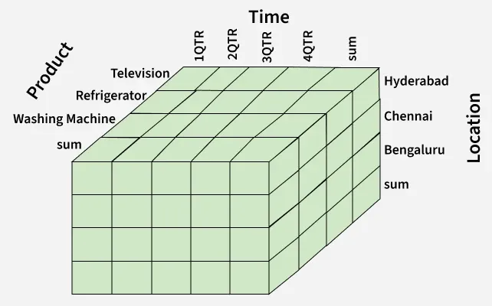

## **Multidimensional Data Representation**

A multidimensional model typically uses:

* Fact Table: Contains measures and foreign keys to dimensions.
* Dimension Tables: Contain attributes that describe context for the facts.
* Cube Representation: Organizes facts across multiple dimensions for faster aggregation and slicing.

## **Working on a Multidimensional Data Model**

Building a multidimensional data model typically involves:

* **Identifying Business Requirements:** Determine the key questions the business wants to analyze (e.g., sales trends, regional performance).
* **Defining Dimensions:** Identify descriptive categories such as time, product, location, or customer that will provide context for analysis.
* **Defining Facts:** Select measurable values such as sales, cost, or units sold that will be stored in the fact table.
* **Identifying Hierarchies:** Establish natural roll-up paths (e.g., Year → Quarter → Month → Day).
* **Designing the Schema:** Create a star or snowflake schema linking fact and dimension tables.
* **Building Data Cubes:** Organize facts and dimensions into cube structures that support slicing, dicing, drill-down, roll-up, and fast aggregation.

## **Example: Understanding the Multidimensional Model**

1. Let us take the example of a firm. The revenue cost of a firm can be recognized on the basis of different factors such as geographical location of firm's workplace, products of the firm, advertisements done, time utilized to flourish a product, etc.

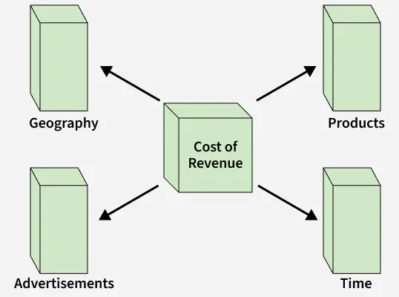

2. Let us take the example of the data of a factory which sells products per quarter in Bangalore. The data is represented in the table given below:

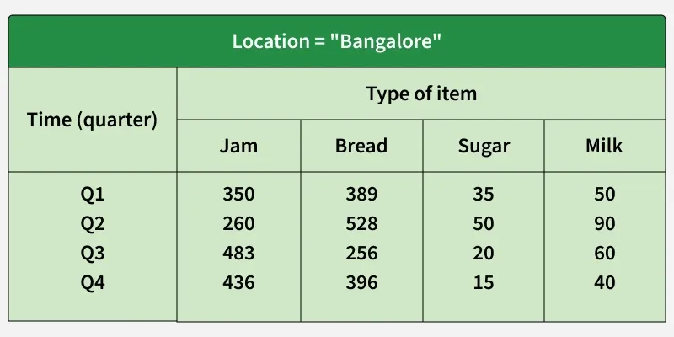In the above given presentation, the factory's sales for Bangalore are, for the time dimension, which is organized into quarters and the dimension of items, which is sorted according to the kind of item which is sold. The facts here are represented in rupees (in thousands).

Suppose we need to add multiple cities (for e.g. Kolkata, Delhi, Mumbai) then the table can be extended as:

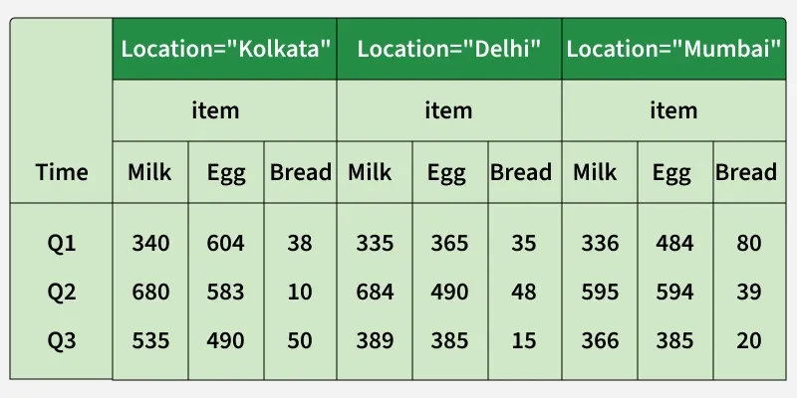

The same data above, can also be represented in the form of three dimensions as given below: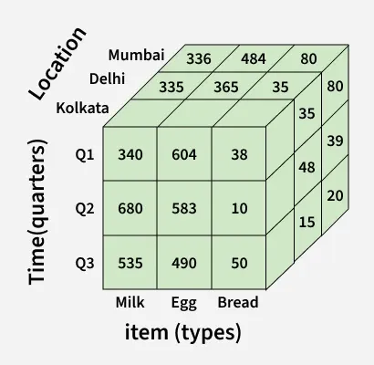

## **Core Components of a Multidimensional Data Model**

* **Measures**: Numerical values used for analysis (e.g., sales, units sold, revenue) -> Stored in fact tables.
* **Dimensions**: Descriptive attributes providing context for measures (e.g., product type, location, time) -> Stored in dimension tables.
* **Cubes**: Multidimensional structures linking facts and dimensions, enabling fast slicing, dicing, aggregation, drill-down, and roll-up.
* **Aggregation**: Summarizing data at higher levels (e.g., daily → monthly → yearly totals) for faster reporting and trend analysis.
* **Drill-Down**: Move from summary to detail (Year → Quarter → Month → Day).
* **Roll-Up**: Move from detail to summary (Day → Month).
* **Hierarchies**: Define levels within each dimension (e.g., Region → State → City), allowing structured navigation of data.
* **OLAP Integration**: OLAP systems use multidimensional models to run complex analytical queries efficiently by leveraging cubes, hierarchies, and aggregations.

# What Is a Data Cube?

According to the formal definition, a *data cube* refers to a multi-dimensional data structure. That is, data within the data cube is explained by specific dimensional values.

Albeit being called a cube, it doesn’t necessarily live in 3 dimensions, nor does it have equal sides as the name suggests. It can be a two-dimensional (2D) table in the form of a rectangle, a 3D solid in the form of a parallelepiped, or even an impossible-to-visualize 4D structure.

Although not so often, we can also talk about zero- or one-dimensional cubes – the former is represented by a single number, while the latter is constructed by an array of numbers.

### What Is an Example of a Data Cube?

Let’s build our understanding of this concept with the help of a toy data cube example. Consider a retail company based in the United States that offers 4 types of clothing – t-shirts, shirts, jeans, and jackets.

The in-house data engineers have gathered information about last year’s revenue (displayed as a one-dimensional array):

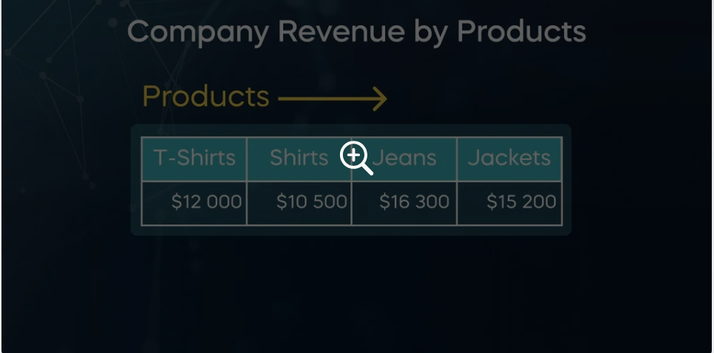

The company, however, has stores in 4 states – California, Hawaii, Indiana, and Michigan. Therefore, the revenue can be split further by products and by states, resulting in a 2D table:

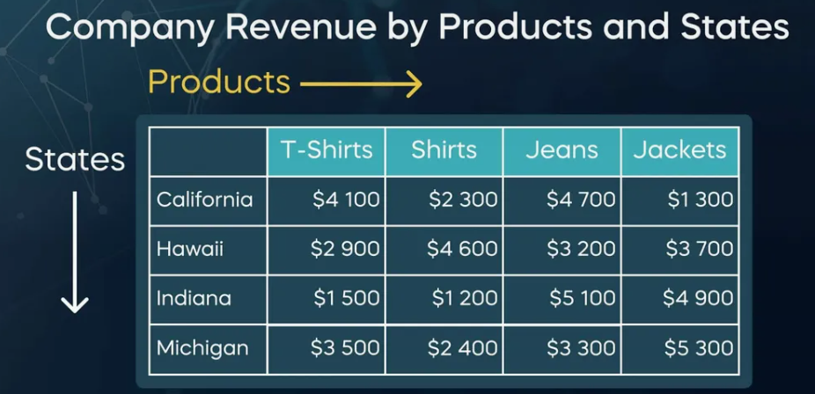Notice that the sum of the numbers along each of the columns gives the total revenue by product. For example, just the t-shirts alone bring in 12 thousand dollars:

$4,100+$2,900+$1,500+$3,500=$12,000

But now, we can sum along the rows as well, such as the annual revenue coming from California:

$4,100+$2,300+$4,700+$1,300=$12,400

We can therefore add one more column next to *Jackets* and call it ‘ALL’. This will represent the annual revenue for each state. Analogously, an additional row (with the same name) can be included below *Michigan*, storing the annual revenue for each product. These 2 dimensions would meet in a cell in the bottom right corner to show the total annual revenue for the chain retail.

What if we wanted to split this revenue by date? For simplicity, we’ll divide the year into quarters. One way to store the information for all 4 is by constructing separate tables for each:

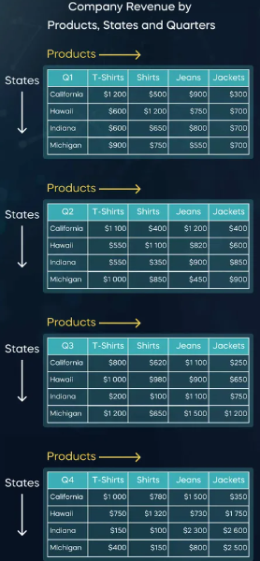

Note that the quarter is specified in the top left cell of each table.

This is not the most elegant solution, is it? As an alternative, we can create a third dimension called ‘Date’ by stacking all 4 tables:

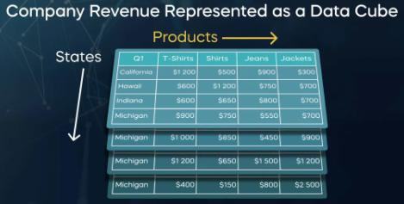

There is now one more dimension that we can sum over. As an example, we’ll calculate the revenue for a full year of t-shirt purchases in Michigan:

$900+$1,000+$1,200+$400=$3,500

Similar to the ‘ALL’ fields for ‘Products’ and ‘States’, we can calculate the total revenue by ‘Date’ as well. In this way, all 3 data cube dimensions will meet in a single data cell, storing the total revenue for a full year.

You are now probably starting to appreciate the functionalities of a data cube. As you can see, it allows us to group data across all dimensions of a cube and retrieve it in an efficient way.

On the other hand, you might be wondering, “What if we added a fourth dimension, say‘Currency’? How do we visualize this data cube?” The truth is that a cube of more than 3 dimensions cannot be visualized in its entirety. Nevertheless, we can still construct it in an analogous way. We call such multi-dimensional cubes by a special name – hypercubes.

### What Are the Elements of a Data Cube?

Now that we’ve laid the foundations, let’s get acquainted with the data cube terminology. Here is a summary of the individual elements, starting from the definition of a data cube itself:

A *data cube* is a multi-dimensional data structure.

A data cube is characterized by its *dimensions* (e.g., Products, States, Date).

Each dimension is associated with corresponding *attributes* (for example, the attributes of the Products dimensions are T-Shirt, Shirt, Jeans and Jackets).

The dimensions of a cube allow for a *concept hierarchy* (e.g., the T-shirt attribute in the Products dimension can have its own, such as T-shirt Brands).

All dimensions connect in order to create a certain *fact* – the finest part of the cube.

A fact has a corresponding *measure* in the data cube. Typically, the fact measure in a data cube for a chain retail business is the *revenue* (such as the $900 revenue from jeans purchases in Indiana during the second quarter).

## What Are the Data Cube Operations?

Data cubes are a very convenient tool whenever one needs to build summaries or extract certain portions of the entire dataset. We will cover the following:

Rollup – decreases dimensionality by aggregating data along a certain dimension

Drill-down – increases dimensionality by splitting the data further

Slicing – decreases dimensionality by choosing a single value from a particular dimension

Dicing – picks a subset of values from each dimension

Pivoting – rotates the data cube

### Rollup

An important feature of data cubes is aggregating data, which results in dimensionality reduction. We do this by grouping the values across a certain dimension, either by taking their sum, average, [standard deviation](https://365datascience.com/tutorials/statistics-tutorials/coefficient-variation-variance-standard-deviation/), or by applying any other *aggregate function*. This dimensionality reduction procedure is known as a *rollup*. I like to imagine it as a zooming out on a data cube.

Let’s view it through the lens of our retail example: summing across the ‘Date’ dimension in the 3D cube returns the 2D table displaying only ‘Products’ and‘States’. If you’re an SQL user, you are well familiar with aggregate functions and know that they are almost always used in combination with the [GROUP BY](https://365datascience.com/tutorials/sql-tutorials/sql-group-by/) clause.

### Drill-down

In contrast, a *drill-down* of a data cube refers to dimensionality increase. In laymen terms, this would be similar to zooming in on a cube. That is, we split the revenue not only by products, but also by states; or make a split not only by products, but also by product brands.

### Slicing

Furthermore, a data cube can also be *sliced*. What that means is to reduce the number of dimensions by keeping one of them fixed. For example, we can slice our 3D data cube and obtain a two-dimensional one by choosing to study the revenue by products and states only for the first quarter of the year.

### Dicing

Rather than extracting a slice from a cube, we can also create a die through *dicing*. This is done by picking certain values from the dimensions. For example, we can choose to see the revenue from shirts and jeans purchases in Hawaii and Michigan during the first and second quarters.

### Pivoting

Lastly, *pivoting* is when we rotate a data cube, allowing for a dimension to be displayed either along its length, width, or depth.

## Data Cube vs Data Warehouse

Data science is anything but lacking in terminology. What often brings confusion among enthusiasts who want to break into this field is how data cubes differ from [data warehouses](https://365datascience.com/trending/data-warehouse/).

### What Is a Data Warehouse?

A data warehouse is the place (typically a cloud storage) where a company’s *historical* data is stored in a *structured* way, usually in the form of [relational databases](https://365datascience.com/tutorials/sql-tutorials/sql-relational-databases/). They can’t be changed, nor deleted. Rather, we can only retrieve information through aggregation or segmentation and use it for analytical, referential, or reporting purposes. Essentially, it is a company’s single source of data truth.

A data cube, on the other hand, refers to the *way* data is structured, as well as how a company might choose to use the cube technology in a data warehouse. Using the multidimensional approach of OLAP data cubes, for example, is only one way of doing this

Mental Image of Multi-Dimensional Cube: COACH AND ME....

**Coach**

The content focuses on the multidimensional model used in data warehousing, which helps in visualizing and analyzing data effectively.

Multidimensional Data Cube

* The model is represented as a three-dimensional data cube with dimensions: product, time, and customer.
* Each dimension can have attributes, such as product category and customer city, which define the data's perspective.

Granularity and Measures

* Granularity refers to the level of detail for measures, such as quantity sold by category, quarter, and city.
* The cube can contain multiple measures, like sales amount, and can be viewed at different granularities.

Dimension Schema and Hierarchy

* Each dimension has a hierarchical structure called the dimension schema, allowing data to be viewed at various levels (e.g., product category and product).
* Members of dimensions can be organized in a tree structure, and data density may vary based on granularity.

#### **Ippe**

What is granularity in the context of a data cube?

#### **Coach**

**Granularity** in the context of a data cube refers to the level of detail at which measures are represented for each dimension. It determines how specific or general the data is within the cube.

For example:

* If the granularity is set to **category, quarter, and city**, the data will show sales figures aggregated at that level.
* A higher granularity (more detailed) might break it down further to individual products sold in specific months, while a lower granularity (less detailed) might summarize data at the yearly level.

Understanding granularity is essential for effective data analysis, as it impacts the insights you can derive from the data.

#### **Ippe**

What is the dimension schema in a data cube?

#### **Coach**

The **dimension schema** in a data cube refers to the hierarchical structure of each dimension, which organizes the attributes of that dimension into levels. This schema allows data to be viewed and analyzed at various levels of detail.

Key points about dimension schema:

* **Hierarchy**: Each dimension can have multiple levels. For example, a time dimension might include levels such as year, quarter, month, and day.
* **Members**: Instances of dimensions are called members, which can be organized in a tree structure, allowing for easy navigation and analysis.
* **Flexibility**: The dimension schema enables users to drill down into more detailed data or roll up to more summarized data, depending on their analytical needs.

This structure is crucial for effective data analysis and reporting in a data warehouse.

#### **Ippe**

What would happen if you changed the granularity of a data cube?

#### **Coach**

Changing the **granularity** of a data cube affects the level of detail and the way data is aggregated. Here’s what happens:

1. **Increased Detail**:
   1. If you increase granularity (e.g., from quarterly to monthly), the data becomes more detailed. You can analyze trends and patterns at a finer level, such as sales per month instead of per quarter.
2. **Decreased Detail**:
   1. Conversely, if you decrease granularity (e.g., from monthly to yearly), the data becomes more summarized. This can make it easier to see overall trends but may obscure specific insights, such as seasonal variations.
3. **Impact on Performance**:
   1. Higher granularity may require more storage and processing power, as more detailed data is being handled. This can affect query performance and response times.
4. **Data Insights**:
   1. The insights derived from the data will vary based on granularity. More granular data can reveal specific behaviors, while less granular data can provide a broader overview.

Adjusting granularity is a key aspect of data analysis, allowing users to tailor their insights based on their specific needs.

[**https://www.researchgate.net/publication/3711076_Summarizability_in_OLAP_and_statistical_data_bases**](https://www.researchgate.net/publication/3711076_Summarizability_in_OLAP_and_statistical_data_bases)

#### **Coach**

The content focuses on the use of multidimensional queues in data analysis, particularly in the context of data warehousing.

Multidimensional Queues

* Data analysts utilize multidimensional queues to analyze data at various levels of detail across different dimensions.
* For example, sales data from cities in Florida can be aggregated to assess overall state performance.

Rolling Up and Drilling Down

* The process of "rolling up" involves looking at broader data, while "drilling down" focuses on finer details.
* This method helps identify specific areas contributing to overall trends, such as low sales in certain cities.

Data Cube Concepts

* Data cubes store pre-calculated levels of detail to expedite data aggregation.
* Key concepts for maintaining data cubes include disjointness (avoiding double counting), completeness (ensuring all parent levels fully decompose), and correctness (using appropriate aggregation functions).

Summarizability Principles

* These principles ensure that data cubes provide accurate insights by following the rules of disjointness, completeness, and correctness.
* Adhering to these concepts allows data analysts to derive meaningful conclusions from their data analyses.

#### **Ippe**

What is disjointness in data cubes?

#### **Coach**

**Disjointness** in data cubes refers to a principle that ensures aggregates are calculated correctly by avoiding double counting of data. Here are the key points:

* **Definition**: Disjointness ensures that each data point belongs to only one category or group within the data cube. This prevents overlap when aggregating data.
* **Example**: If a product group can roll up into two different product types, it must be clearly defined to avoid counting the same data in both categories. For instance, if a product is classified as both "Electronics" and "Home Appliances," it should only be counted in one category to maintain accurate totals.

By adhering to the disjointness principle, data analysts can ensure that their calculations reflect true values without redundancy.

#### **Ippe**

What is completeness in data cubes?

#### **Coach**

**Completeness** in data cubes refers to the principle that every parent level must fully decompose into its child levels. This ensures that all data is accounted for when drilling down into more detailed levels. Here are the key points:

* **Definition**: Completeness ensures that there are no missing data points when moving from a higher-level aggregate to its lower-level components.
* **Importance**: If a parent level does not fully break down into its child levels, some data may be lost, leading to inaccurate analysis and insights.
* **Example**: Consider a sales data cube where the parent level is "Total Sales for Florida." If this level breaks down into cities like Jacksonville and Miami, completeness means that the total sales for Florida should equal the sum of sales from Jacksonville and Miami. If any city’s data is missing, the completeness principle is violated.

By ensuring completeness, data analysts can maintain the integrity and accuracy of their data analyses.

#### **Ippe**

What is disjointness in data cubes?

#### **Coach**

**Disjointness** in data cubes is a principle that ensures aggregates are calculated correctly by preventing double counting of data. Here are the key points:

* **Definition**: Disjointness means that each data point should belong to only one category or group within the data cube. This avoids overlap when aggregating data.
* **Example**: If a product can be classified into two different categories, such as "Electronics" and "Home Appliances," it should only be counted in one of these categories. If it is counted in both, it would lead to inflated totals.

By adhering to the disjointness principle, data analysts can ensure accurate calculations and meaningful insights from their data analyses.

#### **Ippe**

What is completeness in data cubes?

#### **Coach**

**Completeness** in data cubes refers to the principle that every parent level must fully decompose into its child levels. This ensures that all data is accounted for when analyzing at different levels of detail. Here are the key points:

* **Definition**: Completeness ensures that there are no missing data points when moving from a higher-level aggregate to its lower-level components.
* **Importance**: If a parent level does not fully break down into its child levels, some data may be lost, leading to inaccurate analysis and insights.
* **Example**: For instance, if the parent level is "Total Sales for a Region," it should break down into all the cities within that region. If one city’s sales data is missing, the completeness principle is violated, and the total sales figure may not accurately reflect the actual sales.

By ensuring completeness, data analysts can maintain the integrity and accuracy of their data analyses.

#### **Ippe**

How can you ensure correctness in data aggregation?

#### **Coach**

To ensure **correctness** in data aggregation, it's essential to use the appropriate aggregation functions and methods for each measure. Here are some key practices:

* **Choose the Right Function**: Use the correct aggregation function based on the type of data. Common functions include:
  + **Sum**: For total values (e.g., total sales).
  + **Average**: For mean values (e.g., average sales per city).
  + **Count**: For counting occurrences (e.g., number of transactions).
* **Understand Data Types**: Be aware of the data types being aggregated. For example, summing categorical data (like product names) would be incorrect.
* **Define Measures Clearly**: Clearly define what each measure represents to avoid confusion. This helps in selecting the right aggregation method.
* **Validate Results**: After performing aggregation, validate the results by cross-checking with raw data or using sample checks to ensure accuracy.
* **Document Aggregation Logic**: Keep a record of the logic and methods used for aggregation to maintain transparency and facilitate future audits.

By following these practices, data analysts can ensure that their aggregation processes yield accurate and reliable results.

#### **Ippe**

How can you apply summarizability in your analysis?

#### **Coach**

To apply **summarizability** in your analysis, you can follow these key steps:

1. **Define Hierarchies**: Establish clear hierarchies in your data model. This involves defining parent and child relationships among dimensions, ensuring that each parent level can be fully decomposed into its child levels.
2. **Ensure Disjointness**: Make sure that data points are categorized distinctly to avoid double counting. Each data point should belong to only one category within the data cube.
3. **Maintain Completeness**: Verify that all parent levels fully decompose into their child levels. This ensures that no data is lost when drilling down into more detailed levels.
4. **Use Correct Aggregation Functions**: Apply appropriate aggregation functions for each measure based on the data type. This ensures that the results are accurate and meaningful.
5. **Document Aggregation Logic**: Keep a record of the aggregation methods and logic used. This helps in maintaining clarity and allows for easier validation and auditing of results.
6. **Validate Insights**: After performing analysis, validate the insights derived from the data cube against raw data or through sample checks to ensure that the summarization reflects true values.

By implementing these practices, you can effectively apply summarizability in your analysis, leading to accurate and insightful conclusions.

### **1. Question**

**Which type of measure can be meaningfully summarized using addition along all dimensions?**

**Answer:** ✔ *Additive measures*

### **2. Question**

**The cells or facts of a data cube have associated numeric values called**

**Answer:** ✔ *Measures*

### **3. Question**

**Which of the following is an example of a nonadditive measure?**

**Answer:** ✔ *Average price*

### **4. Question**

**Which of the following functions is not distributive?**

**Answer:** ✔ *distinct count*

### **5. Question**

**What does a sparse data cube imply?**

**Answer:** ✔ *Few measures associated with combinations of dimension values*

OLAP Operations in Multi Dimensional Data

Online Analytical Processing Server (OLAP) is used to enable users to perform analysis on information retrieved from multiple database systems concurrently. It operates on a multidimensional data model. Users can write query data across multiple dimensions, such as location, time, and categories (e.g., Hyderabad-> 2017 -> Sales data).

In OLAP, databases are organized into one or more cubes. These cubes are known as Hyper-cubes and represent a multi-dimensional array of data. Each cell within the array corresponds to specific combination of dimension values. The dimensions define the characteristics or attributes. Data can be sliced and diced for analysis by attributes. Examples of dimensions in a sales database are location, time, product category, and customer segment.

OLAP server are efficient and optimized for querying. It uses techniques such as pre-aggregation and indexing. Users can get valuable insights from large volumes of data stored in diverse database systems. OLAP enables complex analysis operations, including drill-down (going from a higher level of summary data to a more detailed level), roll-up (aggregating data to a higher level of summarization), slicing (selecting a specific subset of data based on dimension values), and dicing (analyzing data from multiple dimensions simultaneously). OLAP servers provide a powerful and flexible environment for performing multidimensional analysis.

## OLAP Cube

OLAP cube is also known as a Hypercube. It represents specialized data structure designed for efficient storage and rapid analysis of multidimensional data. Essentially, it captures a snapshot of data at a particular moment in time.

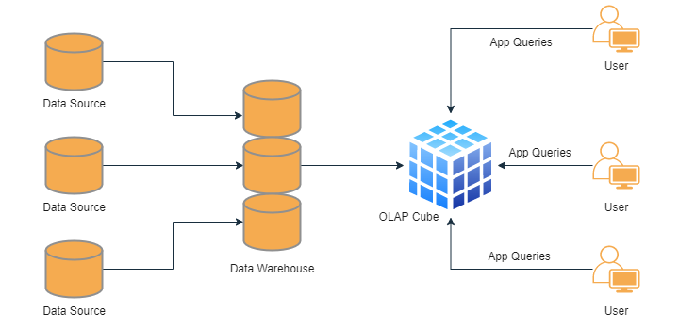

For example, as depicted in the above diagram. It utilizes various OLAP operations. Users can select specific perspective of the hypercube. OLAP cubes provide users to execute analytical queries with multiple dimensions on the available data.

## Types of OLAP Servers

There are three types of OLAP (Online Analytical Processing) systems ?

### **Relational OLAP (ROLAP)**

These systems directly operate on relational databases. These utilize complex SQL queries to retrieve data from the database. They are capable of handling large volumes of data. But they may take more time.

### **Multidimensional OLAP (MOLAP)**

This is considered the traditional form of OLAP. It optimize storage system based on multi-dimensional arrays for data storage. It has positional techniques to access the data physically stored within these multidimensional arrays.

### **Hybrid OLAP (HOLAP)**

It is combination of both ROLAP and MOLAP. It has scalability as advantages of ROLAP systems. It takes less time.

## **OLAP operations**

OLAP operations provide many functionalities to extract valuable insights from data stored in multidimensional hypercubes.

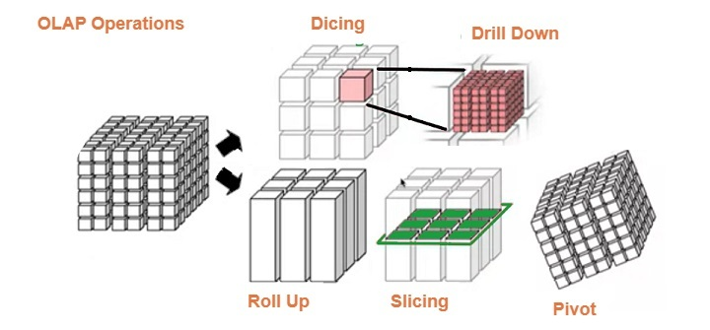

These are explained below.

## Drill Down

Drill Down operation enables users to delve deeper into the data cube. It transforms data with few details into highly detailed data. This can be achieved by either descending through hierarchy concepts for a specific dimension or by introducing additional dimensions to the hypercube.

Performing a drill down operation can be achieved through the following techniques:

### Moving down in the concept hierarchy

It navigates from higher level of aggregation to lower level of detail within a specific dimension. In the given cube, the drill down operation is performed by moving down in the concept hierarchy of the Time dimension from the Quarter level to the Month level.

### Adding a new dimension

This is another approach which introduce new dimension that provides additional granularity. It adds dimension related to a different attribute or aspect of the data. We can analysis and exploration deeply.

For the specific cube given, the drill down operation is moving down in the concept hierarchy of the Time dimension, specifically from the Quarter level to the Month level, to obtain more detailed data about product sales within each city during specific months.

## Roll up

Roll up operation is also known as "drill-up" or aggregation. It is technique used to reduce the dimensionality of a data cube by performing aggregation. It is the opposite of the drill-down operation. Roll up operation aggregates data from a lower level of detail to a higher level by combining similar dimensions across any axis of the cube.

By performing Roll up, the data cube is collapsed along one or more dimensions. It allows for higher-level analysis and a broader view of the data. This aggregation process can be useful for reporting, summarizing data, and extracting key insights from a larger dataset.

Roll-up operation can be achieved through the following techniques:

### Climbing up in the concept hierarchy

This involves navigating from a lower level of detail to a higher level of aggregation within a specific dimension. In the given cube, the roll-up operation is performed by climbing up in the concept hierarchy of the Location dimension from the City level to the Country level.

### Reducing the dimensions

Another approach to roll-up is by reducing the number of dimensions in the data cube. This can be achieved by combining or eliminating dimensions that provide similar or redundant information, resulting in a higher-level summary of the data.

For the specific cube mentioned in the overview section, the roll-up operation is accomplished by climbing up in the concept hierarchy of the Location dimension, specifically from the City level to the Country level, to obtain a higher-level summary of the data aggregated at the country level.

## Dice

Dice operation is technique used to generate new sub-cube from existing hypercube. It selects two or more dimensions from hypercube. It creates new sub-cube that focuses on specific data.

By selecting specific dimensions, the resulting sub-cube contains subset of data that meets the criteria defined by the chosen dimensions. It analysis relevant dimensions and obtain more detailed and specific view of the data.

## Slice

Slice operation is technique used to select single dimension from given cube in order to generate new sub-cube. You can view data from different perspective by isolating specific dimension of interest.

By applying the Slice operation, new sub-cube is created. These contain only the data related to the selected dimension. Slice operation is valuable for analyzing data from different perspectives. You can also analysis specific attributes in isolation. Users can have deeper understanding of the data by exploring its behavior and relationships from the standpoint of a chosen dimension.

## Pivot

Pivot operation is also known as the Rotate operation. Pivot operation is technique used to provide alternate view of the available data to users. It allows for rotating and reorienting the cube's structure to examine the data from different perspectives. Pivot has flexible data analysis and enhances the understanding of the underlying information by presenting it in alternative orientations or arrangements.

Pivot operation enables users to change the orientation of the cube by rearranging the dimensions, resulting in different arrangement of cells and values. This transformation provides new viewpoint for analyzing and interpreting the data.

# **Difference Between OLAP and OLTP in Databases**

|  |  |  |
| --- | --- | --- |
| **Category** | **OLAP (Online Analytical Processing)** | **OLTP (Online Transaction Processing)** |
| Data Source | Historical data from multiple databases. | Current operational data. |
| Purpose | Used for analysis and decision-making. | Used for day-to-day transactions. |
| Method Used | Uses a data warehouse. | Uses a standard DBMS. |
| Normalization | Tables are not normalized. | Tables are normalized (3NF). |
| Query Type | Complex, read-heavy queries (slow). | Simple, read/write queries (fast). |
| Data Volume | Large (TB–PB). | Small (MB–GB). |
| Update Frequency | Updated periodically in batches. | Updated frequently by users. |
| Backup & Recovery | Periodic backup. | Continuous and rigorous backup. |
| Users | Used by analysts, managers and executives. | Used by clerks and operational staff. |
| Focus | Subject-oriented (analysis-focused). | Application-oriented (operation-focused). |

**Data Warehouse Architecture**

# **Data Warehouse Design Approaches**

Designing a data warehouse requires choosing the right approach for how the system will be structured, developed, and scaled. The chosen design impacts data consistency, performance, integration effort, and how quickly insights can be delivered to different teams. There are two common approaches to constructing a data warehouse:

* **Top-Down Approach:** This method starts with designing the overall data warehouse architecture first and then creating individual data marts.
* **Bottom-Up Approach:** In this method, data marts are built first to meet specific business needs and later integrated into a central data warehouse.

## **Components of Data Warehouse Architecture**

A data warehouse architecture consists of several key components that work together to store, manage and analyze data.

* **External Sources:** Where data originates. Includes: Structured (databases, spreadsheets), Semi-structured (XML, JSON) & Unstructured (emails, images)
* **Staging Area:** A temporary space where raw data is cleaned and validated before moving to the warehouse. ETL tools manage this process: Extract (E) - Pulls raw data from sources, Transform (T) - Standardizes and formats the data & Load (L) - Moves the data into the data warehouse
* **Data Warehouse**: A central storage for organized, cleansed data, including both raw data and metadata. Supports analysis, reporting and decision-making.
* **Data Marts**: Smaller, focused sections of the data warehouse for specific teams (e.g., sales, marketing), enabling quick access to relevant data.
* **Data Mining**: Analyzing large datasets in the warehouse to find patterns, trends and insights that support decisions and improve operations.

## **Top-Down Approach**

The Top-Down Approach, introduced by Bill Inmon, is a method for designing data warehouses that starts by building a centralized, company-wide data warehouse. This central repository acts as the single source of truth for managing and analyzing data across the organization. It ensures data consistency and provides a strong foundation for decision-making.

### **Working of Top-Down Approach**

* **Central Data Warehouse:** The process begins with creating a comprehensive data warehouse where data from various sources is collected, integrated and stored. This involves the ETL (Extract, Transform, Load) process to clean and transform the data.
* **Specialized Data Marts:** Once the central warehouse is established, smaller, department-specific data marts (e.g., for finance or marketing) are built. These data marts pull information from the main data warehouse, ensuring consistency across departments.

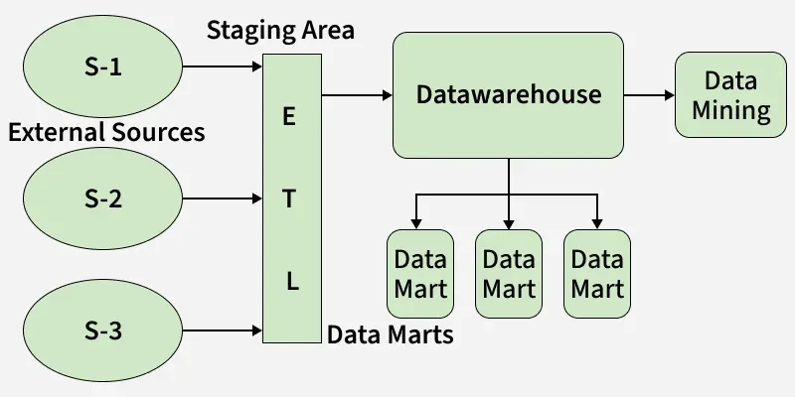**Advantages of Top-Down Approach**

* **Consistent View:** Data marts built from a central warehouse ensure uniform data across departments, reducing reporting discrepancies.
* **High Data Consistency:** Standardizing data through one source minimizes errors and improves the reliability of insights.
* **Simplified Maintenance:** Updates in the central warehouse automatically reflect in all data marts, saving time and effort.
* **Scalable Architecture:** New data marts can be added easily as business needs grow or change.
* **Stronger Governance:** Centralized control improves data security, access management and compliance.
* **Less Data Duplication:** Data is stored once in the warehouse, saving space and avoiding redundant or conflicting records.
* **Better Reporting:** A unified data source enables faster, more accurate reporting and decision-making.
* **Improved Integration:** Central sourcing makes it easier to combine data from multiple systems for deeper analysis.

### **Disadvantages of Top-Down Approach**

* **High Cost & Time:** Building a central data warehouse and data marts requires major investment and long implementation time, making it hard for smaller organizations.
* **Complex Setup:** Designing and managing a centralized system is technically complex and requires skilled resources and careful planning.
* **Low Flexibility:** Predefined structures make it hard to adapt quickly to changing business needs or reporting requirements.
* **Limited User Input:** IT-led development can exclude business users, resulting in solutions that may not meet their actual needs.
* **Data Delays:** Pulling data from various systems can cause processing delays, affecting real-time reporting and insights.
* **Unclear Data Ownership:** Centralization can blur responsibility, making it unclear who manages or maintains specific data.

## **Bottom-Up Approach**

The Bottom-Up Approach, popularized by Ralph Kimball, takes a more flexible and incremental path to designing data warehouses. Instead of starting with a central data warehouse, it begins by building small, department-specific data marts that cater to the immediate needs of individual teams, such as sales or finance. These data marts are later integrated to form a larger, unified data warehouse.

### **Working of Bottom-Up Approach**

* **Department-Specific Data Marts:** The process starts with creating data marts for individual departments or specific business functions. These data marts are designed to meet immediate data analysis and reporting needs, allowing departments to gain quick insights.
* **Integration into a Data Warehouse:** Over time, these data marts are connected and consolidated to create a unified data warehouse. The integration ensures consistency and provides a comprehensive view of the organization’s data.

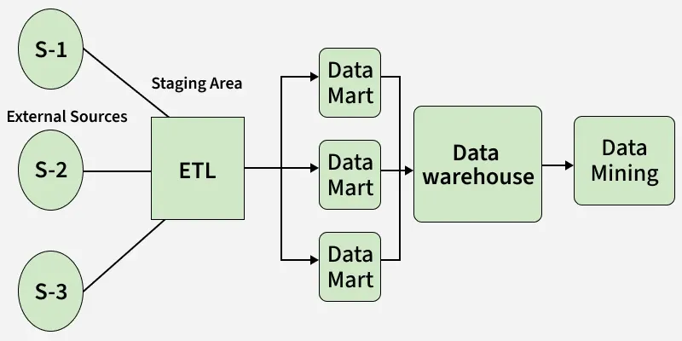

### **Advantages of Bottom-Up Approach**

* **Faster Reporting:** Data marts allow quick insights and report generation.
* **Step-by-Step Development:** Enables gradual rollout with quick wins.
* **User-Centric**: Involves business users to meet actual needs.
* **Highly Flexible**: Easily customized for departments or evolving needs.
* **Quick Results:** Early setup gives immediate value.

### **Disadvantages of Bottom-Up Approach**

* **Inconsistent Views:** Different structures can lead to inconsistent reporting.
* **Data Silos:** Independent marts may cause duplication and isolation.
* **Integration Difficulty:** Combining varied marts into one warehouse is hard.
* **Redundant Efforts:** Similar marts may be built by different teams.
* **Harder to Manage:** Multiple marts increase maintenance overhead. to Manage – Multiple marts increase maintenance overhead.

**Assessment:**

### **1.**

Question 1

What is the main purpose of the roll-up operation in OLAP?

To remove dimensions from a data cube

To aggregate measures along a dimension hierarchy to obtain measures at a coarser granularity

To drill down to a more detailed level in a hierarchy

To filter out data based on a condition

**Correct**

Correct! Roll-up is used to get a broader picture in analysis. This means aggregating measures and moving up the dimension hierarchy from granular to coarser.

**1 / 1 point**

### **2.**

Question 2

Which OLAP operation is the inverse of the roll-up operation?

Pivot

Slice

Drill-down

Dice

**Correct**

Correct!

**1 / 1 point**

### **3.**

Question 3

In the context of OLAP, what is the primary difference between slicing and dicing?

Slicing selects multiple dimensions; dicing selects only one.

Slicing is used for updating data; dicing is used for deleting data.

Slicing selects a single dimension to create a sub-cube; dicing selects two or more dimensions.

Rotates the axes of a cube

**Correct**

Correct! Slicing selects a single dimension to create a sub-cube; dicing selects two or more dimensions.

**1 / 1 point**

### **4.**

Question 4

What does the Pivot (or Rotate) operation in OLAP allow users to do?

Aggregate data into higher-level summaries

Eliminate redundant dimensions from the data cube

Drill into more granular data by adding dimensions

Change the orientation of the cube to view data from different perspectives

**Correct**

Correct! Change the orientation of the cube to view data from different perspectives.

**1 / 1 point**

### **5.**

Question 5

Which of the following is not a benefit of OLAP systems?

Real-time transaction processing

High efficiency in complex analysis

Multidimensional view of data

Support for business intelligence applications

**Correct**

Correct! Real-time transaction processing is not a benefit of OLAP systems.

**1 / 1 point**

### **6.**

Question 6

If you have a Sales cube and you want to add a new measure that calculates the percentage change in sales quantity from 2021 to 2022, which operation should you use?

ADDMEASURE(Sales, PercentageChange = (Quantity2022 - Quantity2021) / Quantity2021)

ROLLUP(Sales, Time ! Year, SUM(Quantity))

SORT(Sales, Product, ProductName)

SLICE(Sales, Time, Year = '2022')

**Correct**

Correct! When we want to compute some new values from already existing measures, we use ADDMEASURE.

**Design Conceptual Multidimensional Models**

# **Difference Between ER Modeling and Dimensional Modeling**

The logical view of data is provided by high level conceptual data model is known as ER model Entity Relationship Model, which represents the Entity, Characteristics, and relationships. It is neccesary to create the databases it is introduced by ralph kimball invented dimensional modelling. which combines denormalized tables and a combination of fact and dimension tables to enable flexible data analysis. Its goal is to optimize data for quick retrieval in business intelligence (BI) systems.

### **Characteristics of ER Modelling**

* **Normalization**: To cut down on redundancy and guarantee data integrity inside the [database](https://www.geeksforgeeks.org/dbms/what-is-database/), ER models frequently concentrate on normalizing data.
* **Diagrammatic Representation**: The ER model makes data structures easier to understand and share by using ER diagrams to visually describe the data.
* **Logical Design**: It guides the establishment of tables, keys, and constraints in relational databases and provides a framework for the logical design of databases.

## **What is Dimensional Modeling?**

Dimensional Modeling is a data modeling technique used primarily in data warehousing and business intelligence. Developed by Ralph Kimball, this approach focuses on optimizing databases for efficient data retrieval and analysis. It involves creating two main types of tables: fact tables and dimension tables. Fact tables store quantitative data, while dimension tables store descriptive attributes related to the facts. Dimensional Modeling is designed to enhance the performance of queries and reports, making it well-suited for analyzing large volumes of historical data.

### **Characteristics of Dimensional Modelling**

* **Emphasis on Business Processes**: Business processes are the focal point of dimensional modelling, which facilitates easier use for reporting and business intelligence needs.
* **Surrogate Keys**: To preserve data integrity and control historical modifications, dimension tables in dimensional models include surrogate keys, which are distinct identifiers independent of the underlying data.
* **Fact and Dimension Tables:** The model is organized into dimension tables that hold context information and descriptive data about the facts, and fact tables that have measurable information.

|  |  |  |
| --- | --- | --- |
| **Parameters** | **ER Modeling** | **Dimensional Modeling** |
| **Orientation** | It is transaction-oriented. | It is subject-oriented. |
| **Core Components** | Entities and Relationships. | Fact Tables and Dimension Tables. |
| **Granularity** | Few levels of granularity. | Multiple levels of granularity. |
| **Types of Information** | Real-time information. | Historical information. |
| **Data Redundancy** | It eliminates redundancy. | It plans for redundancy. |
| **Transaction Volume** | High transaction volumes using few records at a time. | Low transaction volumes using many records at a time. |
| **Data Volatility** | Highly Volatile data. | Non-volatile data. |
| **Model Types** | Physical and Logical Model. | Physical Model. |
| **Normalization** | [Normalization](https://www.geeksforgeeks.org/dbms/introduction-of-database-normalization/) is suggested. | [De-Normalization](https://www.geeksforgeeks.org/dbms/denormalization-in-databases/) is suggested. |
| **Application Types** | [OLTP](https://www.geeksforgeeks.org/dbms/on-line-transaction-processing-oltp-system-in-dbms/) Application. | [OLAP](https://www.geeksforgeeks.org/dbms/olap-operations-in-dbms/) Application. |
| **Example Use Case** | The application is used for buying products from e-commerce websites like Amazon. | Application to analyze buying patterns of the customer of the various cities over the past 10 years. |

## **Conclusion**

Both [ER Modeling](https://www.geeksforgeeks.org/dbms/introduction-of-er-model/) and [Dimensional Modeling](https://www.geeksforgeeks.org/digital-logic/dimensional-data-modeling/) serve distinct purposes in database design and data analysis. ER Modeling is ideal for transactional systems where real-time data processing and integrity are essential, while Dimensional Modeling excels in analytical scenarios where historical data analysis and fast query performance are crucial. Understanding the differences between these models can help in selecting the appropriate approach based on the specific needs of the business and the type of data interactions required.

**Dimensional Data Modeling**

# **Star Schema in Data Warehouse modeling**

A Star Schema organizes data into a central fact table linked to multiple dimension tables, forming a layout that visually resembles a star. This structure makes analytical queries fast, simple, and efficient making it one of the most commonly used data modeling techniques in data warehousing.

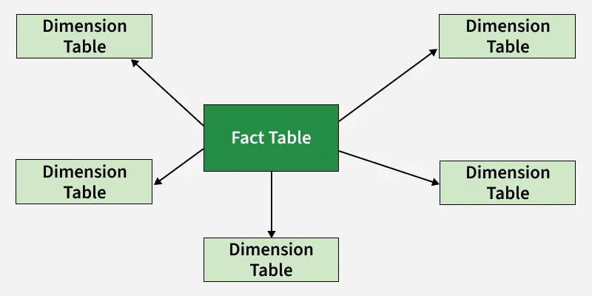

## **Advantages of Star Schema**

* Simpler Queries: Join logic of star schema is quite cinch in comparison to other join logic which are needed to fetch data from a transactional schema that is highly normalized.
* Simplified Business Reporting Logic: In comparison to a transactional schema that is highly normalized, the star schema makes simpler common business reporting logic, such as of reporting and period-over-period.
* Feeding Cubes: Star schema is widely used by all OLAP systems to design OLAP cubes efficiently. In fact, major OLAP systems deliver a ROLAP mode of operation which can use a star schema as a source without designing a cube structure.

## **Disadvantages of Star Schema**

* Redundancy: Denormalized data can introduce duplicates and potential inconsistency if not managed properly.
* Limited Flexibility: Not as adaptable as normalized models when analytical needs change frequently.
* Weak Support for Many-to-Many Relationships: Requires bridge tables or workarounds to model such relationships.

# **Snowflake Schema in Data Warehouse Model**

A Snowflake Schema is a data warehouse modeling technique where dimension tables are normalized into multiple related sub-tables. It is an extension of the Star Schema, designed to handle complex hierarchies and reduce data redundancy. The snowflake effect applies only to dimension tables, not the fact table.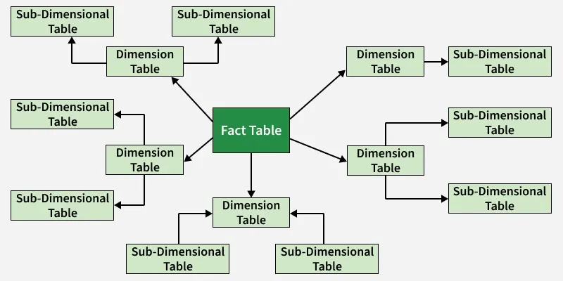

## **Features of the Snowflake Schema**

* **Normalization**: Snowflake schema uses normalized tables to reduce redundancy and improve consistency.
* **Hierarchical Structure**: Built around a central fact table with connected dimension tables.
* **Multiple Levels**: Dimensions can be split into multiple levels, allowing detailed drill-down analysis.
* **Joins**: Requires more joins, which can slow performance on large datasets.
* **Scalability**: Scales well for large data, but its complexity makes it harder to manage.

|  |  |  |
| --- | --- | --- |
| **Feature** | **Star Schema** | **Snowflake Schema** |
| Dimension Structure | Denormalized | Normalized (multiple levels) |
| Query Performance | Faster (fewer joins) | Slower (more joins) |
| Storage Requirement | Higher | Lower |
| Complexity | Simple | More complex |
| Use Case | Simpler analytics, performance-heavy systems | Complex hierarchies, storage optimization |

## **Advantages**

* Improves data integrity through normalization.
* Reduces redundancy and storage usage.
* Supports detailed hierarchical drill-down.

## **Disadvantages**

* Increased schema complexity.
* More joins, leading to slower query performance.
* Normalization may offer minimal storage savings compared to the entire warehouse.
* Not recommended unless the hierarchy is essential and widely used in queries.

# **What is a Hierarchy?**

A **Hierarchy** is a systematic way of organizing the [**Members**](http://olap.com/learn-bi-olap/olap-bi-definitions/dimension-member/) of a [**Dimension**](http://olap.com/learn-bi-olap/olap-bi-definitions/dimension/) into a logical tree structure that defines parent-child [**Aggregation**](http://olap.com/learn-bi-olap/olap-bi-definitions/aggregation/) relationships, where [**Parent Members**](http://olap.com/learn-bi-olap/olap-bi-definitions/parent-member/), i.e., [**Aggregate Members**](http://olap.com/learn-bi-olap/olap-bi-definitions/aggregate-member/), correspond to the consolidation of [**Child Members**](http://olap.com/learn-bi-olap/olap-bi-definitions/child-member/)**.** By arranging Members of a Dimension into a Hierarchy, not only can the OLAP model calculate the aggregation of Dimension Members, but also mathematical calculations in the form of [**Cube Formulas**](http://olap.com/learn-bi-olap/olap-bi-definitions/cube-formula/) can be eliminated since the values for the Child Members will automatically sum up or total to a Parent Member.

**Cardinality:**

In a **Data Warehouse (DWH)**, **cardinality** refers to the *uniqueness* of data values within a column (attribute). It indicates how many distinct values appear in that column.

## **🔹 Types of Cardinality**

Cardinality is usually described in three forms:

### **1. High Cardinality**

A column with *many unique values*  
 Examples:

* Customer ID
* Email address
* Transaction ID
* Timestamp

### **2. Medium Cardinality**

A column with *a moderate number of distinct values*  
 Examples:

* Product names
* Cities
* Departments

### **3. Low Cardinality**

A column with *very few distinct values*  
 Examples:

* Gender (M/F)
* Boolean values (Yes/No)
* Status (Active/Inactive)

## **🔹 Why Cardinality Matters in Data Warehousing**

Cardinality is important because it affects:

### **✔️ Schema design (Star schema vs Snowflake schema)**

High-cardinality attributes are usually placed in **dimension tables**.  
 Low-cardinality columns may become **attributes inside fact tables**.

### **✔️ Indexing strategies**

* High-cardinality → B-tree indexes
* Low-cardinality → Bitmap indexes (common in OLAP systems)

### **✔️ Query performance**

Better understanding of cardinality helps the query optimizer choose efficient join and filtering strategies.

### **✔️ Storage optimization**

Compression works better on low-cardinality columns.

## **🔹 Summary**

**Cardinality = number of unique values in a column.**

* High cardinality → many unique values
* Low cardinality → few unique values
* Important for indexing, schema design, and performance

#### **Ippe**

Explain Primary Events and secondary events

#### **Coach**

Understanding Primary and Secondary Events in Data Analysis

In data analysis, we often encounter two types of events: primary events and secondary events. A primary event is like a snapshot of a specific occurrence, capturing the most detailed information about a fact. For example, imagine a customer buying a coffee at a café. This single purchase, with details like the exact time, the type of coffee, and the amount spent, represents a primary event. It’s the most granular level of data we can collect, allowing us to analyze individual transactions.

On the other hand, secondary events are like a summary of multiple primary events. They aggregate data across various dimensions or hierarchies to provide a broader view. For instance, if we look at all coffee purchases over a week, we can calculate the total sales and average quantity sold. This aggregated data helps businesses identify trends, such as peak sales days or popular coffee types. While primary events give us detailed insights, secondary events help us see the bigger picture.

#### **Ippe**

How can you differentiate between primary and secondary events?

#### **Coach**

Here are the key differences between primary and secondary events in data analysis:

**Primary Events:**

* **Definition:** Specific occurrences of a fact tracked at the most detailed level.
* **Detail Level:** Contains granular data, capturing every detail of an individual transaction or event.
* **Example:** A single purchase of a coffee, including the time, type of coffee, and amount spent.
* **Purpose:** Used for in-depth analysis of individual transactions, allowing for detailed insights.

**Secondary Events:**

* **Definition:** Aggregated data derived from multiple primary events.
* **Detail Level:** Provides a broader overview, summarizing data across various dimensions or hierarchies.
* **Example:** Total coffee sales for a week, including average quantity sold and total revenue.
* **Purpose:** Helps identify trends and patterns, offering insights into overall performance rather than individual transactions.

### **1.**

Question 1

What is a primary event?

An occurrence of a fact identified by one value for each dimension

An occurrence of a fact identified by one n-ple made up of a value for each dimension

An occurrence of a fact identified by one value for each measure

An aggregation of secondary events

**Correct**

Correct! A primary event is a specific instance or record that is identified by a combination of values for all dimensions in the schema, forming a complete n-ple (or tuple) for that event.

**1 / 1 point**

### **2.**

Question 2

What is a secondary event?

A value associated with each measure in a primary event

A particular occurrence of a fact

An aggregation of primary events

A gradually increasing granularity in a hierarchy

**Correct**

Correct! A secondary event results from aggregating multiple primary events, summarizing or combining them based on certain criteria or measures.

**Additivity**

Additivity refers to how we can combine different pieces of data, called facts and measures, to gain insights. Think of it like building a puzzle. Each piece of the puzzle represents a fact, such as a sale made in a store. Each sale has numerical details, like how many items were sold (this is called a measure). When we want to understand the bigger picture, like total sales for a month, we combine these pieces together through a process called aggregation. This is similar to putting together all the puzzle pieces to see the full image.

For example, if you track your daily spending, each day's expenses are like individual sales. By adding up your daily expenses, you can see how much you spent in a week or a month. This helps you understand your spending habits better. Just like that, businesses use additivity to analyze their sales data and make informed decisions.

We can categorize measures based on the property of additivity, showing how they can be aggregated across different dimensions. Aggregation requires defining a suitable operator to compose measure values from primary events into values assigned to secondary events.

From this viewpoint, measures can be classified into three main categories:

* **Flow measures** refer to quantities evaluated over a specified timeframe, summed cumulatively. These measures are typically continuous and are often used to track performance over time. Examples: The number of products sold in a day, Monthly receipts, Yearly number of births.
* **Level measures** are evaluated at specific points in time and represent a snapshot of a status or condition. These measures are cumulative but specific to particular times. Examples: The number of products in inventory at the end of the day, Number of inhabitants in a city at a given time, Account balances at month’s end.
* **Unit measures** are evaluated at specific times but are expressed in relative terms. These measures often represent rates, ratios, or unit-based quantities and are not typically additive. Examples: Product unit price at a specific time, Discount percentage applied during a sale, Currency exchange rate at a given time.

This categorization is similar to the previous classification of measures into additive, semi-additive, and non-additive based on summarizability. However, it differs by providing a more logical and realistic approach. For instance, while semi-additive measures are not summarizable across all chosen dimensions, in practice, they are typically not summarizable across time. This characteristic aligns them with level measures, which are also evaluated at specific points in time. Here is a list of various aggregation functions and how they can be used across temporal (time-based) and non-temporal hierarchies for level, unit, and flow measures:

|  |  |  |
| --- | --- | --- |
|  | **Temporal Hierarchies** | **Non-temporal Hierarchies** |
| Flow measures | SUM, AVG, MIN, MAX | SUM, AVG, MIN, MAX |
| Level measures | AVG, MIN, MAX | SUM, AVG, MIN, MAX |
| Unit measures | AVG, MIN, MAX | AVG, MIN, MAX |

**Assessment:**

### **1.**

Question 1

What is an example of a Flow Measure?

Monthly number of births

Number of products in inventory

Number of inhabitants in a city

Product unit price

**Correct**

Correct! Flow measures represent quantities that are measured or evaluated over a specified timeframe, where they are summed cumulatively, such as the monthly number of births.

**1 / 1 point**

### **2.**

Question 2

What is an example of Level Measure?

Number of employees in each department

Total sales revenue

Monthly number of new clients

Number of products sold

**Correct**

Correct! A Level Measure is evaluated at specific points in time and represents a snapshot of a status or condition. The number of employees in each department provides a snapshot of the workforce at a particular time, making it a Level Measure.

**1 / 1 point**

### **3.**

Question 3

Which type of measure cannot be aggregated using SUM operator along any dimension?

Level measure

Flow measure

Unit Measure

None

**Correct**

Correct! Unit measures, being relative, don’t yield meaningful results when summed. Imagine two cars: Car A has a fuel efficiency of 30 miles per gallon, and Car B has 25 miles per gallon. If you add these together, you get 55 miles per gallon, but this number doesn’t represent anything useful—it doesn’t describe the efficiency of either car or give you combined efficiency.

**Balanced and Unbalanced Hierarchies**

In the world of data warehousing, a balanced hierarchy has two key characteristics. At the schema level, a balanced hierarchy has only one path where all the parent child relationships are many to one and mandatory. This means each child has exactly one parent, and every parent must have at least one child. At the instance level, members form a balanced tree. This means all branches of the hierarchy have the same length ensuring uniformity across a structure.

Let's look at some real world examples to illustrate these concepts. In a time dimension hierarchy, we often see a balanced structure like this. Every year has exactly four quarters, each quarter has three months, and each month has the same structure or days. This uniformity makes it a perfect example of a balanced hierarchy. Let's take a look at another example. Consider an organizational structure where every level has a uniform number of sub levels. Every company has multiple divisions.

Each division has several departments, and each department has multiple teams. The structure remains consistent throughout making it a balanced hierarchy. Balanced hierarchies play a crucial role in data warehousing for several reasons. First is consistency. They ensure data consistency by maintaining a uniform structure across all levels of the hierarchy. Second, is it simplifies the analysis. With a balanced structure, analyzing data becomes easier as each level follows a very predictable pattern.

Next is efficient querying. Queries can be optimized since the hierarchies uniform nature allows for efficient data retrieval. Last, we can get very accurate reporting. Reports generated from balanced hierarchies are more accurate due to the consistent structure. Now, let's talk about unbalanced hierarchies. These are quite different from balanced hierarchies. At the schema level, an unbalanced hierarchy has one path where all parent child relationships are many to one.

However, or more aggregation levels are missing or optional because they are unknown or undefined. At the instance level, members form an unbalanced tree. This means the branches of the hierarchy can have different lengths, leading to an irregular structure. Let's take a look at some examples. In a product hierarchy, we might see an unbalanced structure. Some categories might have subcategories, while others have products directly under the main category without subcategories. This results in different branch lengths.

Another example is one of a geographical hierarchy. In some cases, certain countries might not be divided into states, or some cities might not have neighborhood divisions leading to an unbalanced hierarchy. Unbalanced hierarchies are also significant for several reasons. First is flexibility. They provide flexibility to model real world scenarios where uniform structures are not possible. Next is adaptability. These hierarchies can adapt to incomplete or evolving data, which is common in many business scenarios.

Lastly, they are realistic. Unbalanced hierarchies reflect the actual complexity and variability of real world data. Balanced and unbalanced hierarchies each have their place in housing. Balanced hierarchies ensure consistency and efficiency, while unbalanced hierarchies offer flexibility and realistic modeling. Understanding both types is crucial for effective data management and analysis.

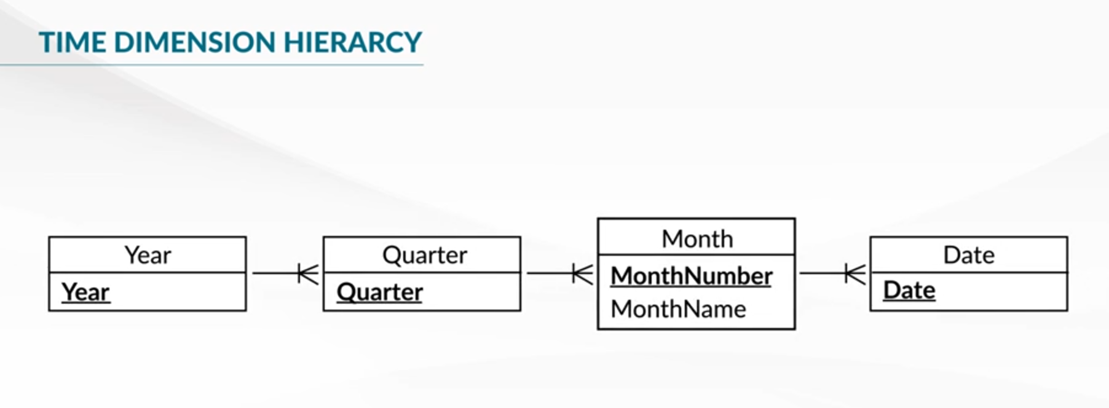

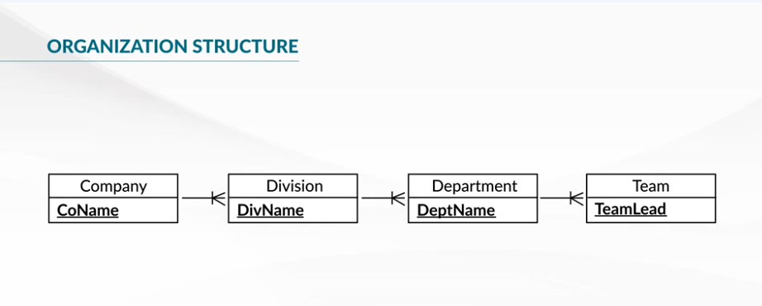

Examples for Balanced Hierarchy

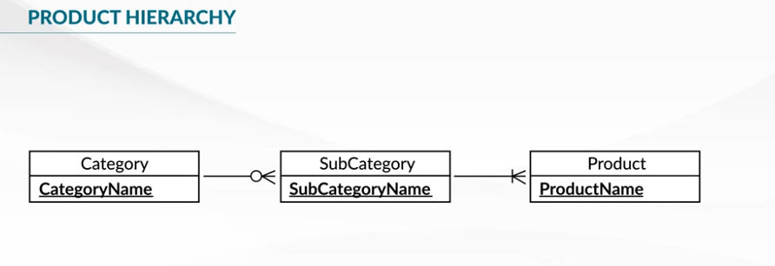

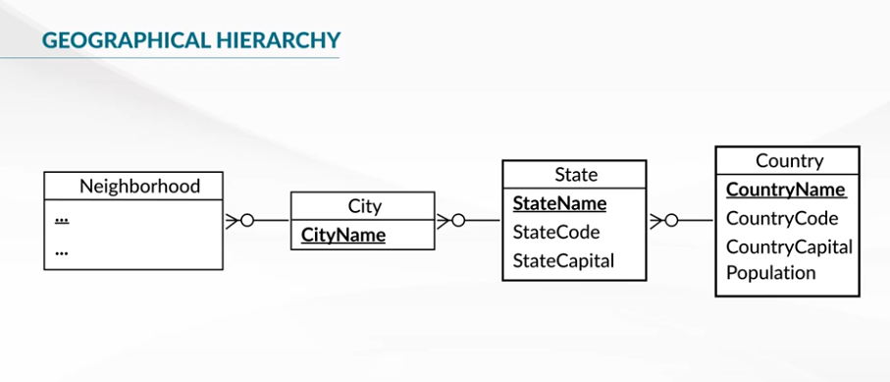Examples for Unbalanced hierarchy.

**Generalized Hierarchy**

In Data Warehousing, generalized hierarchies originate from generalizations and specializations in OLTP, online transaction processing databases. These involve SA relationships between supertypes and subtypes. Let's dive in. Generalized hierarchies start with a supertype like a general customer entity, representing the lowest level of detail in the data warehouse. This supertype can roll up into more specific categories or specializations, such as customer type, professional customers, or corporations.

The next level in the hierarchy could be bank branches. At the schema level, generalized hierarchies have multiple exclusive paths that share data at the leaf level. They may also share data at other levels, creating separate paths for each type of customer. At the instance level, each member belongs to only one path. For example, not all customers may roll up to the sector level or be classified by profession. Let's continue the example with a specific dimensional representation. Some customers are individuals and are classified by their professions while others are companies and are classified by their sectors.

These customers follow different paths on the hierarchy. The level where customers are classified by type like profession or sector is called the splitting level. The level where these paths join is called the joining level. When working with generalized hierarchies, traditional aggregation methods need to be modified. This is because traditional approaches may not work well with splitting and joining levels during drill-down and roll-up operations. For common levels in the hierarchy, traditional aggregation methods can still be used effectively. Not all generalization and specialization hierarchies are easy to represent.

Partial specializations can create additional paths in the hierarchy, linking the common levels. Overlapping specializations pose unique challenges. Various options can be considered based on user needs and available measures. For example, consider a person who owns a company and buys products for personal use and for the company. If measures are known only for the general customer level, only the common hierarchy levels will be represented. If measures are known for each subclass like person and company, separate dimensions and fact relationships can be created. However, this can be difficult to manage due to overlapping members.

Another solution is to disallow overlapping generalizations, simplifying the hierarchy, but possibly reducing flexibility. Generalized hierarchies and Data Warehousing allow for complex and detailed data representation. They offer flexibility but require careful management to handle aggregation and specialization challenges effectively.

**Alternative Hierarchy**

Alternative hierarchies represent different ways to organize the same dimension. For example, they allow us to look at data from various perspectives, like different ways of analyzing time. Marketing teams may use a conventional calendar based view of time. While accounting teams may use a fiscal calendar, which looks different. At the schema level, alternative hierarchies involve multiple non-exclusive paths that share at least the leaf level.

These paths account for the same analysis criterion. At the instance level, members of alternative hierarchies form a graph. Alternative hierarchies are needed to analyze measures from different perspectives using alternative paths. Each measure participates fully in each hierarchy, allowing us to use conventional aggregation procedures. However, it is not correct to combine different hierarchies at the same time. Doing so can create meaningless intersections, like combining data for different time periods that don't make sense together such as combining data from both fiscal Q1 2021 and calendar year 2021. Users must choose only one of the alternative paths for their analysis.

If needed, they can switch to another path for a different perspective. Let's compare generalized hierarchies and alternative hierarchies. Both types of hierarchies share some levels and use only one analysis criterion. In generalized hierarchies, a child member belongs to only one path. In alternative hierarchies, a child member relates to all paths, but users must choose one path for analysis. Alternative hierarchies provide flexibility in how we analyze data, offering different ways to look at the same dimension. They allow us to see data from various perspectives, making our analysis more comprehensive.

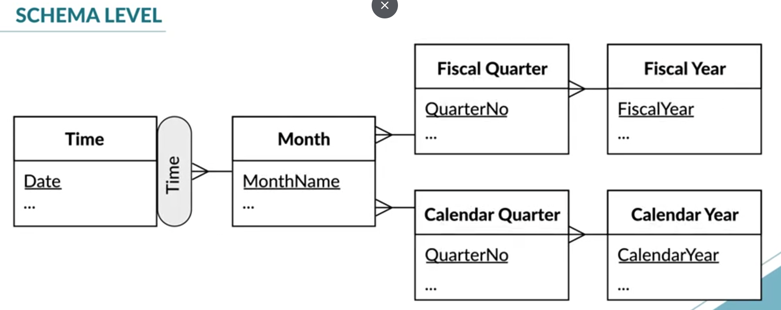

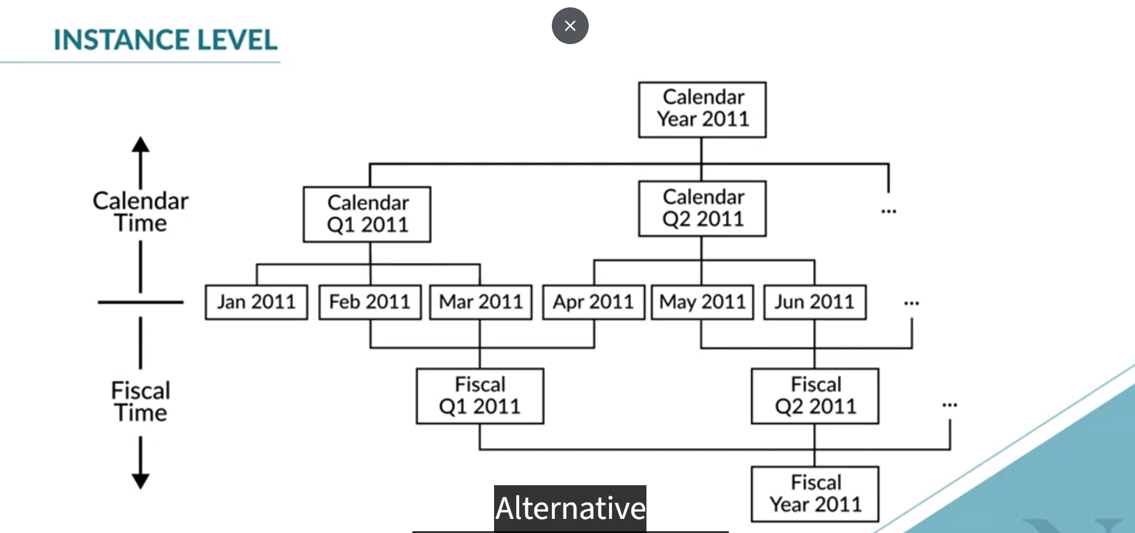

**Parallel Hierarchy**

There are two types of parallel hierarchies; independent and dependent parallel hierarchies. Parallel independent hierarchies consist of separate independent paths that do not intersect. Each path offers a unique way to analyze data, but they do not combine at any level. For example, consider analyzing products by product groups and distributor location. Each has its own hierarchy.

You might analyze sales by product category like seafood and distributor region like the Northeast. These paths are independent and can be combined for analysis. Parallel dependent hierarchies are composed of several hierarchies that account for different analysis criteria and share some levels. Imagine a store analyzed by location city and geography in one hierarchy and by sales district in another. The common level, such as state, might have different values in each hierarchy, reflecting different organizational structures. With parallel hierarchies, it is often useful to combine perspectives from different hierarchies. However, storing pre-computed aggregations at the common levels is not usually meaningful.

Parallel hierarchies in data warehousing are a powerful tool for analyzing data from multiple perspectives. They offer representation of real-world organizational structures and are helpful in modeling them accurately and effectively.

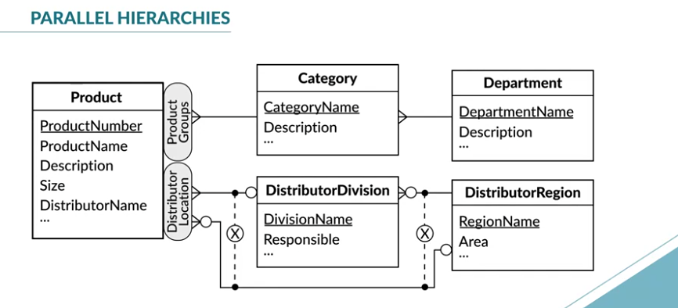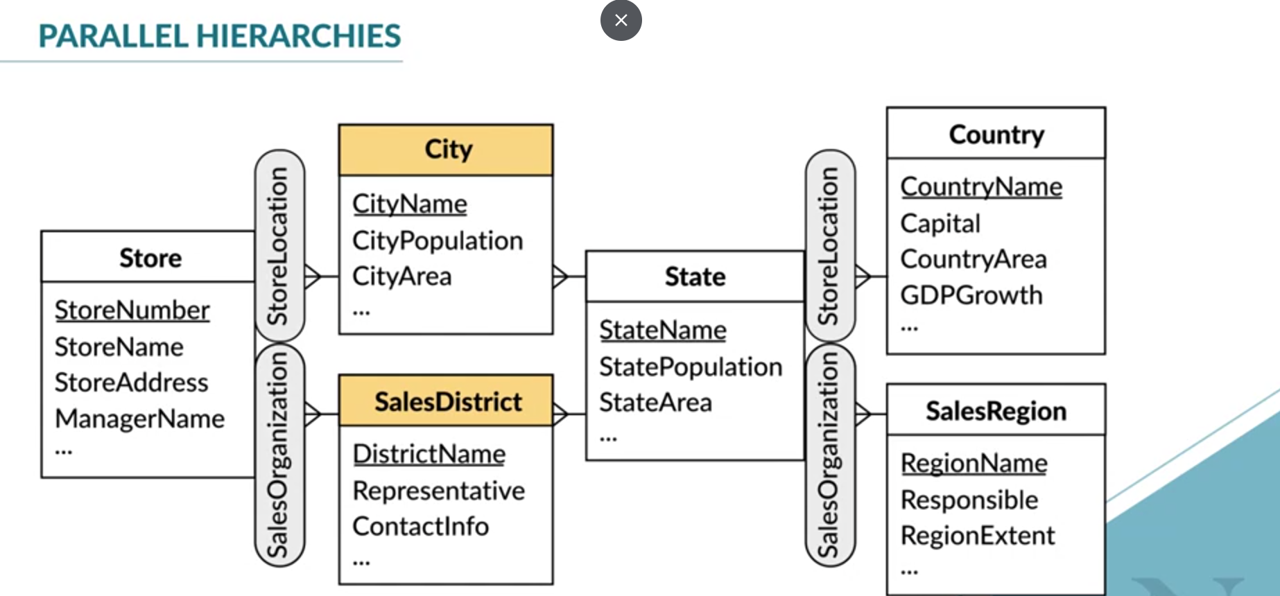

**Assessment**

### **1.**

Question 1

How is an unbalanced hierarchy different from a balanced hierarchy at the schema level?

One or more missing/optional aggregation levels

One path with many-to-one relationships

Multiple paths with many-to-one relationships

No parent-child relationships

**Correct**

Correct! An unbalanced hierarchy has levels that do not contain the same number of elements or do not cover all the levels completely, leading to some aggregation levels being optional or missing.

**1 / 1 point**

### **2.**

Question 2

What defines a *parent-child* or *recursive* hierarchy?

Same-level elements linked by roles of parent-child relationships

A hierarchy with multiple branches of varying lengths

A hierarchy with a single path and mandatory relationships

A hierarchy with only one branch

**Correct**

Correct! A recursive hierarchy is one where elements on the same level are linked by parent-child relationships, meaning a node can be both a parent and a child at different levels of the hierarchy.

**1 / 1 point**

### **3.**

Question 3

What is another term for Level-skipping hierarchies where alternative paths are obtained by by skipping one or several intermediate levels?

Incomplete hierarchies

Ragged/Non-covering Hierarchies

Generalized hierarchies

Unbalanced hierarchies

**Correct**

Correct! Ragged or non-covering hierarchies are also called level-skipping hierarchies because they skip levels, leading to an uneven structure where some paths are shorter or longer than others. They are a special case of generalized hierarchies.

**1 / 1 point**

### **4.**

Question 4

Which of the following is true for a parallel hierarchy?

Hierarchies that do not intersect at any level

Multiple hierarchies that converge at the top level

Hierarchies that have the same root but diverge into different paths

Separate hierarchies that coexist and allow for different paths to aggregate data

**Correct**

Correct. Parallel hierarchies are separate hierarchies that coexist within the same system, allowing for multiple paths to aggregate data independently.

**1 / 1 point**

### **5.**

Question 5

Alternative hierarchies require users to choose ______ path(s) for analysis at a time.

All

Multiple

None

One

**Correct**

Correct! Alternative hierarchies provide different paths for analyzing data, but users typically choose one path at a time for their analysis to ensure clarity and focus.

### **1.**

Question 1

In a non-strict hierarchy, if Node A has parents B and C, what does it imply?

Node B and Node C can be at different hierarchy levels.

Node B and Node C must be at the same hierarchy level.

Node A cannot have any children.

Node A must have multiple children.

**Correct**

Correct! In a non-strict hierarchy, a node can have multiple parents at different levels, meaning Node B and Node C can be at different levels in the hierarchy.

**1 / 1 point**

### **2.**

Question 2

What role does the concept of double counting play in hierarchical data analysis?

It indicates the total number of nodes in the hierarchy.

It affects the accuracy of statistical analyses.

It helps identify nodes with multiple parents.

It determines the hierarchy's depth.

**Correct**

Correct! Double counting occurs when a value is counted more than once due to overlapping hierarchies or multiple paths, which can distort statistical analysis and lead to inaccurate results.

**1 / 1 point**

### **3.**

Question 3

What is the purpose of using a bridge table in a many-to-many relationship in a data warehouse?

To simplify data retrieval by denormalizing the schema

To eliminate redundant data from the dim ension tables

To resolve the many-to-many relationships between fact and dimension tables

To store historical snapshots of fact table records

**Correct**

Correct! A bridge table is used to handle many-to-many relationships between fact and dimension tables, allowing for the correct association of records without duplicating data.

**Fact Constellation**

Fact Constellation in Data Warehouse modeling is a schema design that integrates multiple fact tables sharing common dimensions, often referred to as a "Galaxy schema." This approach allows businesses to conduct multi-dimensional analysis across complex datasets.

* Fact Constellation Schema, also known as the Galaxy Schema, is an advanced [data modeling technique](https://www.geeksforgeeks.org/data-analysis/data-modeling-a-comprehensive-guide-for-analysts/) used in designing data warehouses. Unlike simpler models like the [Star Schema](https://www.geeksforgeeks.org/dbms/star-schema-in-data-warehouse-modeling/) and [Snowflake Schema](https://www.geeksforgeeks.org/dbms/snowflake-schema-in-data-warehouse-model/), the Fact Constellation Schema consists of multiple [fact tables](https://www.geeksforgeeks.org/software-testing/what-is-a-fact-table/) that share common [dimensional tables](https://www.geeksforgeeks.org/software-testing/what-is-a-dimension-table/).
* This model is ideal for handling complex systems and large-scale analytical queries, offering flexibility for [business intelligence](https://www.geeksforgeeks.org/power-bi/what-is-business-intelligence/) and [data mining](https://www.geeksforgeeks.org/data-science/data-mining/).
* The core components of the Fact Constellation Schema include Fact Tables and Dimension Tables. Fact tables store measurable, quantitative data, such as sales or revenue, while dimension tables store descriptive attributes like time, location, or product. These tables are interconnected, with multiple fact tables sharing the same dimension tables.

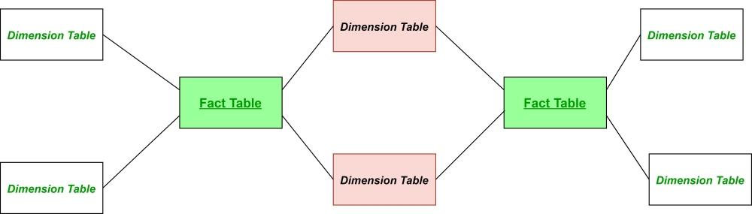

Logical modeling of data warehouses is an essential step in creating an efficient and effective data warehousing solution. Understand the different types of OLAP schemas; star schema, snowflake schema, fact constellation schema. Together, these form relational OLAP schemas, as well as multi-dimensional OLAP and hybrid OLAP allows data architects to choose the appropriate schema based on the specific requirements of their business environment. Each schema has its own strengths and use cases. Star Schema is ideal for environments prioritizing query performance and simplicity. A Snowflake schema is best for scenarios, requiring data normalization and integrity. Constellation schema is used where there are complex and large-scale environments needing to analyze multiple business processes.

Multi-dimensional OLAP is best for scenarios needing very fast query responses and manageable data volumes. Hybrid OLAP offers a balanced approach for environments, requiring both fast performance and scalability. By carefully selecting and implementing the right OLAP schema, organizations can ensure that data warehouse supports robust, efficient and insightful data analysis.

**Assessment**

### **1.**

Question 1

Which OLAP system stores multidimensional data in relational databases?

MOLAP

HOLAP

ROLAP

POLAP

**Correct**

Correct! ROLAP (Relational OLAP) uses relational databases to store multidimensional data. It relies on SQL to handle OLAP tasks, making it a good choice for systems that use relational databases for storing large volumes of data.

**1 / 1 point**

### **2.**

Question 2

What’s one of the main benefits of using MOLAP systems?

Large storage capacity

Standardization

Efficient OLAP operations

Complex SQL queries

**Correct**

Correct! MOLAP (Multidimensional OLAP) systems use specialized multidimensional structures that speed up OLAP operations. This setup helps in retrieving and analyzing data quickly and efficiently.

**1 / 1 point**

### **3.**

Question 3

What’s a common drawback of star schemas?

Complex maintenance

Redundant data in dimensions tables

Difficult to query

Limited storage capacity

**Correct**

Correct! In a star schema, dimension tables are not normalized, which can lead to repeated information. Example: In a product dimensions, if a category appears in many rows, the same category details are repeated, causing redundancy.

**1 / 1 point**

### **4.**

Question 4

What’s typically included in a constellation schema?

One fact table and one dimension table

Multiple fact tables sharing dimension tables

Only normalized dimension tables

Only unnormalized dimension tables

**Correct**

Correct! AA constellation schema is characterized by having multiple fact tables that use the same set of dimension tables. This setup helps in organizing complex data relationships and makes it easier to analyze data from different perspectives.

**1 / 1 point**

### **5.**

Question 5

If you need to use different levels of normalization for different dimensions, which schema might you choose?

Snowflake schema

Constellation schema

Starflake schema

Hybrid schema

**Correct**

Correct! A starflake schema mixes elements from both star and snowflake schemas. It allows you to have some dimensions normalized while keeping others denormalized, giving you flexibility based on your data needs.

**1 / 1 point**

### **6.**

Question 6

Consider the following SQL query:

SELECT s.sales_amount,

c.customer_name,

r.region_name,

p.product_name,

ct.city_name

FROM Sales s

JOIN Customer c ON s.customer_id = c.customer_id

JOIN City ct ON c.city_id = ct.city_id

JOIN Region r ON ct.region_id = r.region_id

JOIN Product p ON s.product_id = p.product_id

WHERE r.region_name = 'North America';

Based on the structure of the SQL query, determine whether the query is part of a:

Star Schema

Snowflake Schema

**Correct**

Correct! This query is part of a snowflake schema. In the query, the Customer table is normalized into smaller tables like City and Region. This normalization of dimension tables (where Customer is linked to City, and City is linked to Region) is a characteristic of a snowflake schema, as opposed to a star schema where all dimension data would typically be denormalized and stored in a single dimension table.

## **What are Surrogate Keys?**

A surrogate key is a unique identifier for each row in a table, which is typically a sequential number generated by the system. Unlike natural keys, which are derived from the business data (e.g., Social Security Number, email address), surrogate keys are devoid of any business meaning. They are purely artificial and are used solely for the purpose of uniquely identifying a record within a database table.

## **Benefits of Surrogate Keys**

1. **Uniqueness and Consistency:** Surrogate keys ensure that each record in a table has a unique identifier, which is crucial for maintaining data integrity. They remain consistent over time, even if the business data changes, unlike natural keys which might need to be updated if the underlying business data changes.
2. **Simplicity and Performance:** Surrogate keys are typically simple integers, which makes indexing and searching operations faster compared to complex natural keys. This simplicity also reduces the storage requirements for indexes.
3. **Anonymity and Security:** Since surrogate keys do not contain business information, they add a layer of security and anonymity. This can be particularly important in scenarios where data privacy and protection are concerns.
4. **Handling Data Integration:** In a data warehouse, data often comes from multiple source systems, each with its own natural key format. Surrogate keys provide a uniform method for uniquely identifying records across these diverse systems, simplifying the process of data integration.
5. **Historical Tracking:** Surrogate keys facilitate the implementation of Slowly Changing Dimensions (SCDs), which are used to manage historical data and track changes over time in a data warehouse.

## **Implementation of Surrogate Keys in a Data Warehouse**

Surrogate keys are typically implemented using auto-incrementing fields or sequences in a relational database management system (RDBMS). Consider these key points:

1. **Primary Key:** In dimension tables, the surrogate key serves as the primary key. This ensures that each dimension record is uniquely identified.
2. **Foreign Key Relationships:** Fact tables use surrogate keys from dimension tables as foreign keys. This creates a consistent and efficient means of joining fact and dimension tables during query operations.
3. **Surrogate Key Generation:** Surrogate keys are generated using mechanisms such as auto-increment fields (in MySQL), sequences (in Oracle and PostgreSQL), or identity columns (in SQL Server).

Data consistency is a cornerstone of any effective data warehouse. It ensures that data is accurate, reliable, and uniform across the system, providing a solid foundation for data analysis and decision making. In the context of data warehousing, consistency refers to maintaining data in a coherent state, both in terms of structure and content, across various data sources and over time. We will address the importance of data consistency, the challenges involved, and best practices for maintaining consistent data in a data warehouse.

## **The Importance of Data Consistency**

1. **Accurate Reporting and Analysis:** Consistent data is essential for accurate reporting and analysis. Discrepancies in data can lead to incorrect insights, which can affect strategic business decisions.
2. **Trust and Credibility:** Consistent data builds trust among stakeholders. When data is reliable and consistent, it enhances the credibility of the reports and analyses generated from the data warehouse.
3. **Integration of Multiple Data Sources:** Data warehouses often integrate data from various sources. Ensuring consistency across these sources is critical for creating a unified and coherent dataset.
4. **Operational Efficiency:** Consistent data reduces the need for data cleaning and rework, thereby improving operational efficiency and reducing the time required to generate reports and analyses.

Challenges & Best Practices for Maintaining and Ensuring Data Consistency

## **Challenges in Maintaining Data Consistency**

1. **Heterogeneous Data Sources:** Data warehouses typically consolidate data from multiple sources, each with its own format, structure, and update schedule. Harmonizing this data can be challenging.
2. **Data Volume and Complexity:** Large volumes of data and complex data structures increase the difficulty of ensuring consistency. Managing consistency at scale requires robust processes and tools.
3. **Changes in Source Systems:** Changes in source systems, such as schema updates, data migrations, or software upgrades can introduce inconsistencies in the data warehouse.
4. **Timeliness of Data Updates:** Ensuring that data is consistently updated across all systems in a timely manner is crucial. Delays in data updates can lead to temporary inconsistencies.
5. **Surrogate Keys:** Surrogate keys are typically used in data warehouses instead of natural or business keys. Keeping data consistent with surrogate keys adds an additional layer of complexity to populating data in a data warehouse.
6. **Denormalized:** Data in star schemas push the burden of data consistency onto the ETL process, which then must ensure this consistency of data.

## **Best Practices for Ensuring Data Consistency**

1. **Data Validation and Cleansing:** Implement robust data validation and cleansing processes to detect and correct inconsistencies at the time of data ingestion. This includes checking for data completeness, accuracy, and adherence to predefined business rules.
2. **Master Data Management (MDM):** Use MDM to create a single, authoritative source of truth for key business entities. MDM helps ensure that all systems use consistent definitions and values for these entities.
3. **ETL Processes:** Design efficient Extract, Transform, Load (ETL) processes that standardize data from various sources before loading it into the data warehouse. Using ETL tools can automate the transformation and normalization of data, ensuring consistency.
4. **Data Governance:** Establish a strong data governance framework that includes policies, procedures, and standards for maintaining data consistency. Data governance involves defining roles and responsibilities, data stewardship, and setting up data quality metrics.
5. **Regular Audits and Monitoring:** Perform regular audits and monitoring of data to identify and rectify inconsistencies. Use data profiling and quality monitoring tools to continuously assess the state of data consistency.
6. **Metadata Management:** Maintain comprehensive metadata that describes the structure, relationships, and rules governing the data. Metadata management helps ensure that all users understand the data and its context, reducing the likelihood of inconsistent usage.
7. **Data Integration Tools:** Leverage data integration tools that support real-time data synchronization and provide capabilities for conflict detection and resolution.

Let's go over some examples of what we mean when we say consistency in data. Consider a retail data warehouse that integrates sales data from online and in store systems. Ensuring data consistency involves, firstly, data validation. Checking that sales data from both systems conforms to a unified format and a set of business roles. Second, ETL processes, transform and normalize data during the ETL processes to align with the data warehouse systems. Third, master data management, MDM, using MDM to ensure that product ids, customer ids, and other key identifiers are consistent across both systems. Lastly, data governance, establishing governance policies to manage changes in source systems and to maintain data quality.

Maintaining data consistency in the data warehouse is critical for ensuring the accuracy, reliability, and credibility of the data used for business analysis and decision making. By implementing best practices such as robust data validation, ETL processes, master data management, and strong data governance. Organizations can overcome the challenges of data consistency and build a trustworthy data warehousing environment. Ensuring consistent data not only enhances operational efficiency, but also provides a solid foundation for deriving actionable insights and driving business success.

**What Is Prepopulating Dimensions?**

**Prepopulating dimensions** means **filling a dimension table *in advance*** with all the possible values it might need *before* any fact data arrives.

You basically "prepare" the dimension ahead of time rather than waiting for real data.

# **Why Do We Prepopulate Dimensions?**

Because some dimensions are **fixed** or **known ahead of time**, such as:

* Time (years, months, days)
* Geography (countries, regions, cities)
* Product categories
* Organizational structure (departments, branches)

Instead of creating these rows when facts (e.g., sales transactions) come in, you **load them** **upfront** so the data warehouse is ready for any future fact records.

Simple Example

### **Time Dimension**

You know there will be days from 2020 to 2030.

So instead of waiting until a sale happens on a day to insert that date, you **create all dates upfront**:

|  |  |  |  |  |
| --- | --- | --- | --- | --- |
| **date_key** | **full_date** | **month** | **quarter** | **year** |
| 20230101 | 2023-01-01 | Jan | Q1 | 2023 |
| 20230102 | 2023-01-02 | Jan | Q1 | 2023 |
| ... | ... | ... | ... | ... |

Now your fact table can use these records anytime.

Let's go over an example of pre populating dimensional data. Consider a retail data warehouse that needs to analyze sales over time and across different regions. Pre-populating the time dimension might involve creating entries for every day over the next ten years, including attributes like day of the week, month, and fiscal quarter. For the geography dimension, it might involve creating entries for all cities in a country, including attributes like state, region, and country. This pre-population ensures that sales data can be accurately aggregated and analyzed by any time period or geographic location, even if some regions have not yet reported sales data. Pre-populating dimensions such as time and geography is a crucial practice in data warehousing. It ensures that the data warehouse is equipped to handle comprehensive and accurate analysis, improves performance, and maintains data consistency.

By preloading these critical dimensions, organizations can future proof that data warehouses and ensure that they are always ready to provide valuable insights, regardless of the completeness or timeliness of the underlying data.

**Assessment**

### **1.**

Question 1

What is a primary purpose of using surrogate keys in a data warehouse?

To enhance data security

To simplify data integration and maintain consistency

To increase the complexity of queries

To maintain historical accuracy

**Correct**

Correct! Surrogate keys are used to uniquely identify records without relying on business data, simplifying data integration and maintaining consistency across different source systems.

**1 / 1 point**

### **2.**

Question 2

Why might a data warehouse choose to use a database key rather than a surrogate key?

To improve query performance

To reduce complexity during the ETL process

To ensure data anonymity

To simplify indexing operations

**Correct**

Correct! Using database keys can reduce complexity in the ETL process by avoiding the need to generate and manage surrogate keys.

**1 / 1 point**

### **3.**

Question 3

Which best practice helps ensure data consistency across different data sources?

Using complex data validation rules

Implementing robust data validation and cleansing processes

Regularly changing data formats

Ignoring source system changes

**Correct**

Correct! Effective data validation and cleansing processes detect and correct inconsistencies, ensuring consistent data across sources.

**1 / 1 point**

### **4.**

Question 4

Why is prepopulating the time dimension important in a data warehouse?

To reduce the number of data entries

To improve query performance and ensure completeness

To limit data storage requirements

To increase the complexity of the ETL process

**Correct**

Correct! Prepopulating the time dimension ensures that all possible time periods are accounted for, improving query performance and completeness.

# **Mapping Process**

## **Mapping Process: From Conceptual to Logical**

1. **Identify Core Business Processes:**
   1. Start by identifying the core business processes that need to be analyzed. These processes will guide the creation of fact tables.
2. **Determine Key Entities and Attributes:**
   1. Based on the conceptual model, identify the key entities and their attributes. These will become dimension tables and their columns in the logical model.
3. **Establish Fact Tables:**
   1. Define fact tables based on the business processes, incorporating measures and foreign keys to dimension tables.
4. **Design Dimension Tables:**
   1. Create dimension tables with primary keys and relevant attributes. Include hierarchies to facilitate OLAP operations.
5. **Define Relationships and Hierarchies:**
   1. Establish foreign key relationships between fact tables and dimension tables, ensuring referential integrity. Model the various types of hierarchies within these dimension tables.

# **Understanding Slowly Changing Dimensions**

## **Introduction**

In data warehousing, dimensions are critical components that provide context to the measurable facts stored in fact tables. However, as business entities evolve over time, the attributes of these dimensions also change. Handling these changes efficiently and accurately is essential for maintaining the integrity of the data warehouse. In this video, we discuss the concept of Slowly Changing Dimensions (SCDs), exploring their types, significance, and best practices for implementation.

## **Understanding Slowly Changing Dimensions**

A Slowly Changing Dimension (SCD) refers to a dimension that changes slowly over time, rather than on a regular schedule. These changes might include updates to customer information, product details, or employee records. Managing these changes is crucial to ensure historical accuracy and to enable accurate trend analysis over time.

# **Types of Slowly Changing Dimensions**

There are several types of Slowly Changing Dimensions, each addressing different business requirements and data update scenarios. The primary types are SCD Type 1, SCD Type 2, SCD Type 3, and the less common but useful SCD Types 4, 5, and 6.

**1. SCD Type 1: Overwriting**

* **Description:** In SCD Type 1, when a change occurs, the old data is overwritten with the new data. This method does not maintain any historical data.
* **Use Case:** Suitable when historical accuracy is not required, and only the current state of the data is important.
* **Example:** Updating a customer's phone number. The old phone number is replaced with the new one. The phone number is not used in any data analysis and only used as a means of communication with the customer.

**2. SCD Type 2: Versioning**

* **Description:** In SCD Type 2, historical data is preserved by creating a new record for each change. Each record is assigned a unique version number or a date range to indicate its validity.
* **Use Case:** Suitable when it is essential to maintain the history of changes for audit or trend analysis purposes.
* **Example:** Tracking changes in a customer's address over time.

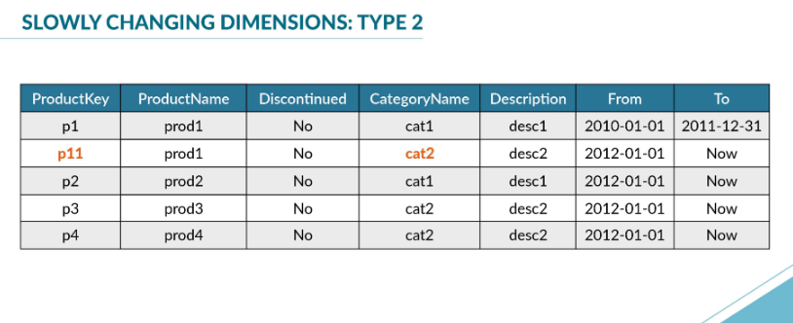**3. SCD Type 3: Adding New Attributes**

* **Description:** In SCD Type 3, changes are tracked by adding new attributes to the dimension table to store previous values. This method maintains limited history.
* **Use Case:** Suitable when only a limited history is needed, such as the previous and current value.
* **Example:** Storing both the current and previous product category.

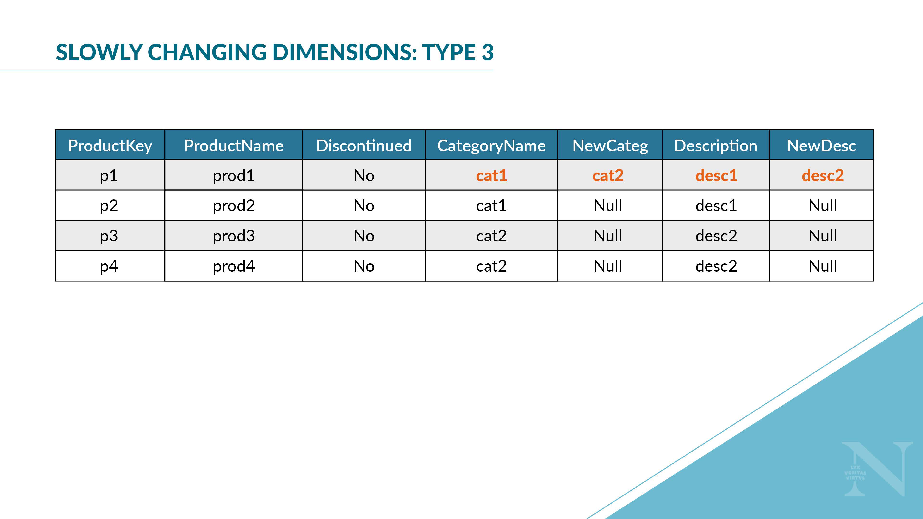

**4. SCD Type 4: Historical Table**

* **Description:** In SCD Type 4, a separate historical table is used to track changes. The main dimension table keeps only the current data, while the historical table stores the history.
* **Use Case:** Suitable for scenarios where the current and historical data need to be separated for performance or organizational reasons.
* **Example:** Keeping a historical table for customer addresses while the main table contains the latest address.

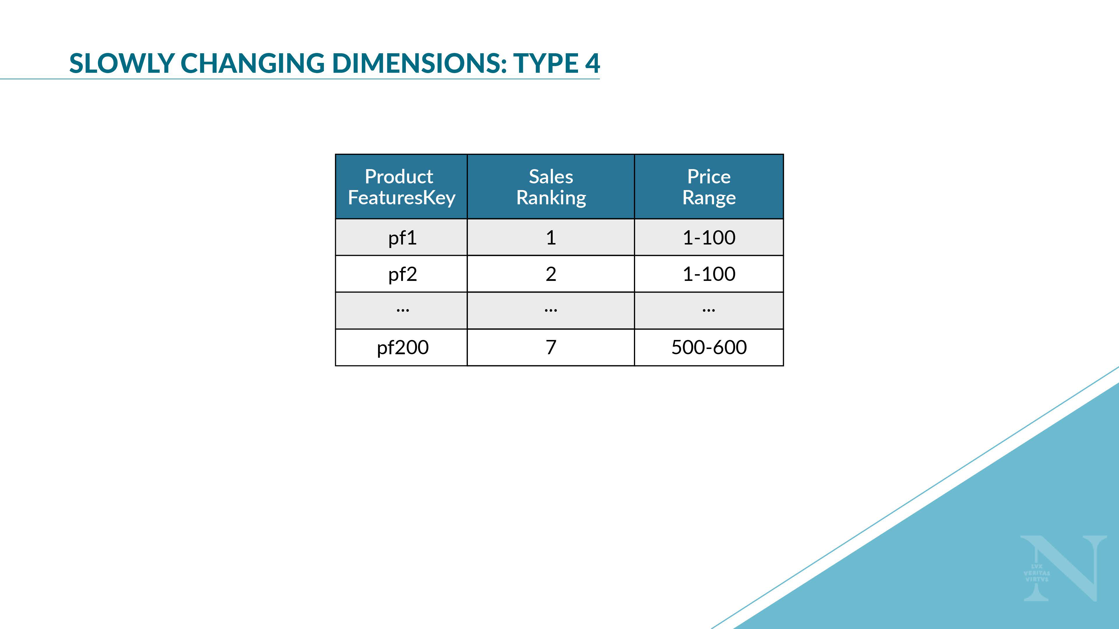

**5. SCD Type 5: Mini Dimension**

* **Description:** In SCD Type 5, a mini-dimension is created to handle rapidly changing attributes. This mini-dimension is then linked to the main dimension table.
* **Use Case:** Useful when dealing with attributes that change frequently and would otherwise cause excessive updates to the main dimension table.
* **Example:** A mini-dimension for frequently changing customer preferences.

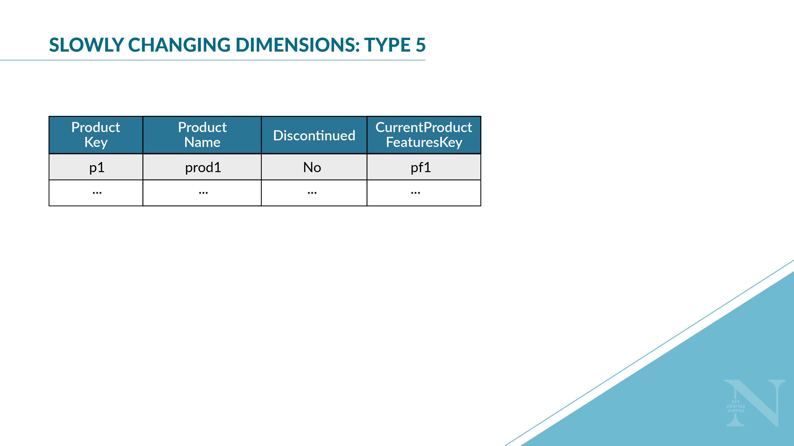

**6. SCD Type 6: Hybrid Approach**

* **Description:** SCD Type 6 combines the techniques of SCD Types 1, 2, and 3. It maintains both current and historical data, as well as additional columns for tracking the most recent changes.
* **Use Case:** Suitable for complex scenarios where a combination of techniques is required to meet business needs.
* **Example:** Tracking customer address changes with both historical records and previous values in the main dimension table.

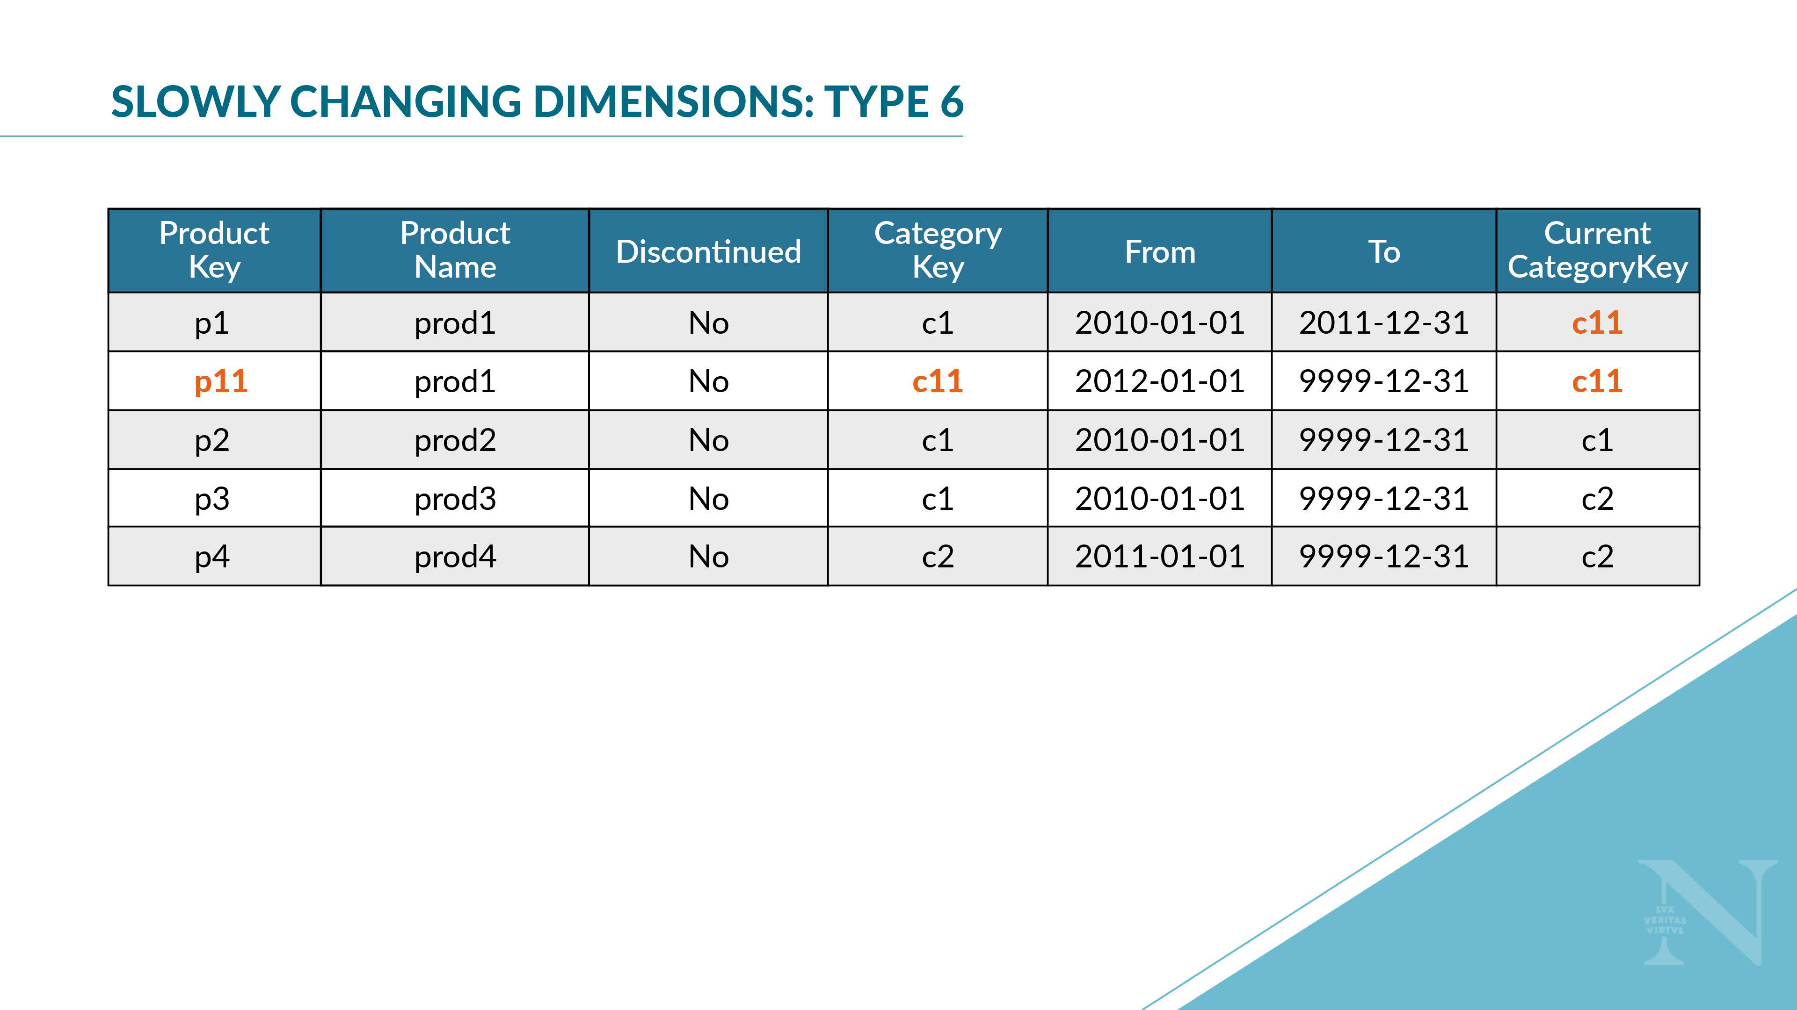

# Benefits of Managing Slowly Changing Dimensions

1. **Historical Accuracy:**
   1. Ensures that historical data is preserved, enabling accurate trend analysis and reporting.
2. **Audit Trail:**
   1. Provides a clear audit trail of changes, essential for regulatory compliance and data governance.
3. **Improved Analysis:**
   1. Enhances the ability to perform detailed and accurate business analysis, such as tracking customer behavior over time.
4. **Data Integrity:**
   1. Maintains data integrity by accurately reflecting the state of the data at different points in time.

There are five main best practices for implementing slowly changing dimensions that you should be aware of. One, identify business requirements. Understand the business needs and requirements for historical data. Choose the appropriate SCD type based on these requirements. Two, design efficient ETL processes. Design extract, transform, and load processes that efficiently handle changes in dimension data. This includes detecting changes, updating records, and maintaining data integrity.

Three, use surrogate keys. Employ surrogate keys in dimension tables to uniquely identify records and manage changes without affecting the natural keys. Four, maintain metadata. Keep detailed metadata about the dimension changes, including version numbers, effective dates, and change reasons. Five, optimize for performance. Optimize the dimension tables and ETL processes for performance, especially when dealing with large volumes of data. Slowly changing dimensions are a fundamental aspect of warehouse design, enabling the accurate and efficient management of changing dimension data.

By understanding and implementing the appropriate SCD type, businesses can maintain historical accuracy, provide a robust audit trail, and support comprehensive analysis and reporting. Whether through overwriting versioning, adding new attributes, creating historical tables, using mini-dimensions or hybrid approaches, handling changes in dimension data effectively is crucial for the long-term success of a data warehouse.

Why translate between SCD’s?

* Changing Business Requirements
* Performance Optimization
* Data Governance and Compliance
* Improving Data Quality

# **Steps for Translating Between SCD Types**

1. **Assess Current and Target SCD Types:**
   1. Understand the characteristics of the current SCD type and the target SCD type. Identify the differences in how historical data is managed.
2. **Define Business Requirements:**
   1. Gather requirements from business stakeholders to ensure the new SCD type meets all analytical and reporting needs.
3. **Design the Transition Plan:**
   1. Develop a detailed plan that outlines the steps needed to translate the data. This includes mapping old records to the new structure, identifying necessary transformations, and planning for data migration.
4. **Prepare the ETL Process:**
   1. Design and implement an ETL (Extract, Transform, Load) process to handle the transition. This process should extract data from the current SCD structure, transform it to fit the new structure, and load it into the new SCD type.
5. **Validate and Test:**
   1. Conduct thorough testing to ensure that the translation process preserves data integrity and accuracy. Validate the new SCD structure against business requirements and historical accuracy.
6. **Migrate the Data:**
   1. Execute the ETL process to migrate the data to the new SCD structure. Monitor the process closely to address any issues that arise.
7. **Update Reporting and Analytics:**
   1. Modify existing reports and analytics to work with the new SCD structure. Ensure that all users are trained on any changes to how data is accessed and interpreted.
8. **Maintain Documentation:**
   1. Document the entire translation process, including the reasons for the change, the steps taken, and any changes to data governance policies.

Let's now look at some specific examples of translating between SCD types. The first example, we translate from SCD type 1 to SCD type 2. A company initially chose SCD type 1 for its customer dimension, where customer addresses were simply overwritten. However, they now need to track historical addresses for better trend analysis. The challenge here is that historical data was not preserved in type 1. How do we implement this? We implement a new ETL process to start capturing changes, create new records with effective dates, and back full historical data where possible.

There are some limitations though. It is possible that the historical data has gaps forever. In the second example, let's look at translating from SCD type 2 to SCD type 3. A retail chain uses SCD type 2 to track historical store locations. However, they decide that only the previous and current locations are necessary, not the entire history. The challenge here is that type 2 uses new records for changes, whereas type 3 uses additional columns. We need to convert from records to columns.

Converting records to include old and new value columns as part of the ETL, discontinue new records for changes and update the ETL processes to manage column based historical tracking. There are some limitations here as well. Type 3 has less history than type 2. It's possible that users are impacted by the loss of history. There are many more types of changes, and it is crucial for you to think deeply about the desired outcome as you approach the problem of translating between the SCDs.

**ASSESSMENT**

### **1.**

Question 1

How does a star schema typically represent a balanced hierarchy?

By using multiple fact tables

By normalizing all dimension tables into different levels

By linking all dimension levels directly to the fact table

By using bridge tables

**Correct**

Correct! In a star schema, all dimension levels directly link to the fact table, which is effective for balanced hierarchies.

**1 / 1 point**

### **2.**

Question 2

How can unbalanced hierarchies be transformed into balanced ones?

By adding placeholder levels

By normalizing all dimensions

By removing lower levels

By using bridge tables

**Correct**

Correct! Placeholders are used to fill in the gaps in unbalanced hierarchies, making all branches equal in length.

**1 / 1 point**

### **3.**

Question 3

What does a generalized hierarchy allow in a data warehouse model?

The use of multiple fact tables

The use of multiple foreign keys at different levels

Different aggregation paths for dimension members

The representation of time-series data

**Correct**

Correct! Generalized hierarchies accommodate members that may aggregate along different paths, requiring additional rules to ensure correct queries.

**1 / 1 point**

### **4.**

Question 4

Which method is commonly used to manage nonstrict hierarchies in a data warehouse?

Normalization of dimension tables

Use of surrogate keys

Bridge tables

De-normalization

**Correct**

Correct! Bridge tables are used to manage nonstrict hierarchies by properly linking dimension members to multiple levels, avoiding double counting.

**1 / 1 point**

### **5.**

Question 5

A retail company has a product hierarchy: Department > Category > Subcategory > Product. However, some categories do not have subcategories. What type of hierarchy is this, and how should it be modeled?

Balanced hierarchy; no special modeling is required.

Unbalanced hierarchy; use placeholders for the missing subcategories.

Generalized hierarchy; create multiple paths for each category.

Nonstrict hierarchy; create a bridge table for categories.

**Correct**

Correct! An unbalanced hierarchy requires placeholders to fill in the missing levels, ensuring that all paths in the hierarchy can be aggregated correctly.

**1 / 1 point**

### **6.**

Question 6

A retail company tracks its product sales using two distinct ways of organizing its data:

**Category Hierarchy:**

Electronics > Laptops > Dell XPS 13

Electronics > Tablets > Apple iPad

**Brand Hierarchy:**

Dell > Electronics > Dell XPS 13

Apple > Electronics > Apple iPad

Given the product examples, which type of hierarchy is used to organize data based on different perspectives on the same products?

Parallel hierarchy

Alternative hierarchy

Balanced hierarchy

Unbalanced hierarchy

**Correct**

Correct! In this example, the Category Hierarchy and the Brand Hierarchy are used to organize the same products but from different perspectives. The Category Hierarchy allows analysis based on product categories and subcategories (e.g., Laptops vs. Tablets), while the Brand Hierarchy allows analysis based on brands (e.g., Dell vs. Apple). Since these hierarchies coexist independently and provide different views of the data, they represent a parallel hierarchy.

**1 / 1 point**

### **7.**

Question 7

In a data warehouse, you have a dimension where some products belong to multiple categories (e.g., a multi-category product like a "smartwatch" that fits into both "Wearable Electronics" and "Smart Devices"). Which approach should be used to handle this many-to-many relationship?

Use a bridge table to link products to categories

Include multiple category columns in the product table

Create a separate dimension for each category

Store the product in only one category

**Correct**

Correct! A bridge table allows for the representation of many-to-many relationships, where products can be linked to multiple categories. This approach provides flexibility and maintains the integrity of the dimensional model.

**1 / 1 point**

### **8.**

Question 8

You are designing a data warehouse for a retail company that tracks sales transactions at daily as well as monthly levels. Consider the following scenarios:

* On August 10, 2024, a store sells a high-end laptop for $2,000.
* For the month of August 2024, the company makes a monthly sales tax payment of $45,000 to the state government, covering all transactions for that month.

Both of these facts need to be recorded in the FinancialTransactions fact table, but at different granularities. To ensure that the FinancialTransactions fact table can accurately represent and aggregate data at both levels of granularity, which approach would be the most effective?

Use separate foreign keys for daily and monthly dimensions, ensuring only one foreign key is populated for each record

Create separate fact tables for daily and monthly transactions, and join them during querying

Flatten the FinancialTransactions fact table to include columns for both daily and monthly data, resulting in a very wide table

Use a single dimension table that combines both daily and monthly granularity levels

**Correct**

Correct! Using separate foreign keys for daily and monthly dimensions allows the FinancialTransactions fact table to efficiently handle data at both granularities. In this approach, for daily transactions like the laptop sale, the DayKey is filled while MonthKey is null. For monthly transactions like the tax payment, MonthKey is filled while DayKey is null.